The CARIBBEAN VILLAGE Insider CULTURE-ZINE
Volume 2, Issue 3, January 2023

Happy New Year 2023

Greetings Patrons, Partners and Friends,
In CARIBBEAN VILLAGE’S continued interest in educating, edifying and inspiring our readers - with even MORE truth and facts about “all things Caribbean”, we will try something a little different this month. We will explore the connection between Spain’s Canary Islands, the U.S. State of Louisiana and the Caribbean.
We ask for your continued readership and support during 2023, as the CULTURE-ZINE strives to become a powerful testimony to the diversity, tenacity, strength, intelligentsia and reach of Caribbean people and the diaspora.

The FOUNDER’S Word

Blessings and Greetings for the NEW YEAR Friends!!

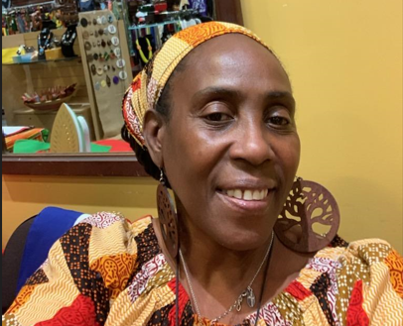
This month the CULTURE-ZINE proudly features an interesting conversation with Native Pittsburgher and Educator, Brandon Jamare Drew, about his travel to Spain’s Canary Islands. As usual, included in this issue is edifying information about the history, culture and geography of the featured, Canary Islands. Also included is a link to experience the Whistled Language of this region. I hope our content makes you want to explore other Caribbean linkages throughout our world!

I’ll see you Inside….

Table of Contents
Volume 2, Issue 3, January 2023

Pages 1: Welcome and The Founder’s WORD
Page 2: Table of Contents
Page 3: The Flag and Coat of Arms of The Canary Islands
Page 4: Canarian History, Culture & Geography
Page 7: An Interview with Pittsburgh Native Son, Brandon J. Drew
Interviewed By: Keywanda Battle
Page 12: Gastro Caribe
Page 15: BOOK of the Month
Page 16: Scenes from each of the Canary Islands
Page 23: The VEXILLOLOGY
Page 24: WHERE in the World??
Page 25: Come VISIT CARIBBEAN VILLAGE
Page 26: Caribbean Village OFFER
Page 27: Building STRONG Business Communities through ADVERTISING
Page 29: Canary Islands Flag Youth Coloring Page
Page 30: Volume 1 of the CARIBBEAN VILLAGE Insider CULTURE- ZINE
Page 31: Volume 2 of the CARIBBEAN VILLAGE Insider CULTURE- ZINE
Page 32: PRODUCER’S Advertising Page
To open the Links in this E-Zine, Simply CLICK the Link

The Flag and Coat of Arms of The Canary Islands
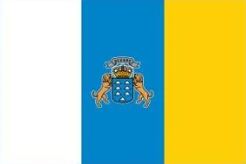
The Canary Islands have had their own Flag since August 10, 1982. The flag is a vertical tri-color of three equal bands of white, blue, and yellow. The placement of the colors is derived from the physical location of the islands. WHITE on the left corresponds to Tenerife’s western location. YELLOW on the right corresponds to the eastern location of Gran Canaria. BLUE, in the middle is the common color.
The Canary Islands, also known as the Canaries, are a Spanish autonomous community and archipelago in Macaronesia in the Atlantic Ocean. At their closest point to the African mainland, they are 62 miles west of Morocco. The Canaries are the southernmost of the autonomous communities of Spain.

Coat Of Arms
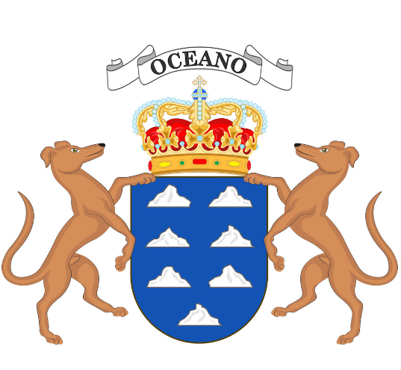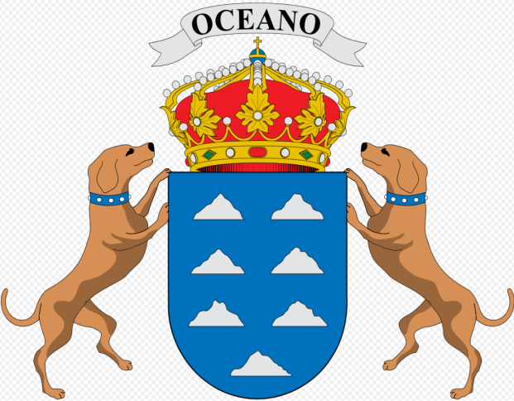
The word “Oceano” appears at the top of the Coat Of Arms above the Spanish Royal Crown. Seven [7] islands are represented in silver on an azure blue background with a Dog on either side, as supporters. The representation of the Dogs comes from the Latin translation of “Insula Canaria”, meaning Island of the Dogs.

The Controversy:
Whether the Dogs should appear collared or un-collared is a point of contention and controversy. Some Canarians feel the collar reflects submission and should be removed. One of the political parties, however, does not support the idea of removing the symbolism of the collar from the coat of arms so the proposal to remove has not been passed.

The Canary Islands are not an independent state, but an independent community.

Canary Islands History, Culture & Geography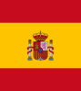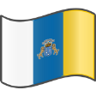
Canary Islanders, or Canarians [Spanish: canarios], are an ethnic group. They reside on the Canary Islands, an autonomous community of Spain near the coast of northwest Africa, and descend from a mixture of European settlers and aboriginal Guanche peoples. Genetics shows modern Canarian people to be, on average, a population of mostly European ancestry, with some Northwest African admixture. The distinctive variety of the Spanish language spoken in the region is known as habla Canaria [Canary speech]. The Canarians, and their descendants, played a major role during the conquest, colonization, and eventual independence movements of various countries in Latin America. The Canarian ethnic and cultural presence is most palpable in the countries of Uruguay, Venezuela, Cuba, the Dominican Republic and Puerto Rico.
Isleños are the inhabitants of the Canary Islands, and by extension the descendants of Canarian settlers and immigrants to present-day Louisiana, Texas, Cuba, the Dominican Republic, Venezuela, Puerto Rico, and other parts of the Americas. In fact, whole towns and villages in Puerto Rico were founded by Canarian immigrants, and their lasting influence of Canarian culture can still be heard in the Puerto Rican accent and seen in the cuatro, a small guitar with origins in the Canary Islands.
HISTORY
The original inhabitants of the Canary Islands are commonly known as Guanches [this term in its strict sense only refers to the original inhabitants of Tenerife]. They are believed to be related to the Berber peoples of northern Africa.

The islands were conquered by Castile at the beginning of the 15th century. In 1402, they began to subdue and suppress the native Guanche population. The Guanches were initially enslaved and gradually absorbed. As a result, genetic analyses of modern Canarians show mainly a mixture of European and North African genes.

After subsequent settlement by Europeans, the remaining Guanches were gradually assimilated by the settlers and their culture largely vanished. Alonso Fernández de Lugo, conqueror of Tenerife and La Palma, oversaw extensive immigration to these islands during a short period from the late 1490s to the 1520s from mainland Europe, mostly Castile and Portugal.

Historically, the Canary Islands served as a hub between Spain and the Americas. Large groups of Canary Islanders emigrated and settled all over the New World as early as the 15th century, mainly in Cuba, Puerto Rico, Dominican Republic, Colombia, Venezuela and Uruguay.

CULTURE
Modern-day Canarian culture is Spanish, with some Guanche influences. Some of the Canarian traditional sports such as:
- lucha canaria ["Canarian fight"],
- juego del palo ("stick game") and
- salto del pastor ("shepherd's jump"), among others, have their roots in Guanche culture.
Additionally, other traditions include:
- Canarian pottery
- Words of Guanche origin in the Canarian speech

Also, the inhabitants of La Gomera retain an ancient way of communicating across deep ravines by means of a whistled speech called Silbo Gomero. This indigenous whistled language was invented by the Guanches. La Gomera (pronounced [la ɣoˈmeɾa]) is one of Spain's Canary Islands. It is the third smallest of the eight main islands of this archipelago.

Whistled languages emulate speech and facilitate communication. A whistled language is a system of whistled communication which allows fluent whistlers to transmit and comprehend a potentially unlimited number of messages over long distances. It is well worth your while to audibly experience this!! TO LISTEN, Click the link or Copy/Paste the link into browser https://youtu.be/TfGwFM9-wFk

The HOLIDAYS celebrated in the Canary Islands are of international, national and regional or insular character, for example:
- The official day of the autonomous community is Canary Islands Day on May 3oth.
- The most famous festival of the Canary Islands is the carnival. The carnival is celebrated in all the islands and all its municipalities. The busiest two being those of the two Canarian capitals; the Carnival of Santa Cruz de Tenerife (Tourist Festival of International Interest) and the Carnival of Las Palmas de Gran Canaria. It is celebrated on the streets between the months of February and March.
- The rest of the islands of the archipelago have their carnivals with their own traditions.

The strong influence of Latin America in Canarian culture is due to the constant emigration and return over the centuries of Canarians to that continent, chiefly to Puerto Rico, Cuba, the Dominican Republic, Venezuela and Uruguay. To a lesser extent, they also went to the U.S. State of Louisiana (mostly the southern portion) and Texas (mostly in and around San Antonio), as well as, some areas in eastern Mexico including Nuevo León and Veracruz.

GEOGRAPHY
Canary Islands, Spain GPS Coordinates are:
28° 17' 29.6340'' N and 16° 37' 44.8644'' W
Physically, the Canaries fall into two groups. The western group, made up of Tenerife, Gran Canaria, La Palma, La Gomera, and Ferro islands, consists of mountain peaks that rise directly from a deep ocean floor. The eastern group comprises Lanzarote, Fuerteventura Island, and six islets surmounting a single submarine plateau, the Canary Ridge, that rises about 4,500 feet from the ocean floor.
The Canary Islands were formed by volcanic eruptions millions of years ago. All the western islands exceed 4,000 feet at their highest points, with Teide Peak on Tenerife rising to 12,198 feet, the highest point on Spanish soil.
The Canary Islands have a subtropical climate. Temperatures are warm and show little seasonal variation. The islands’ rich volcanic soils and mild temperatures support a wide variety of vegetation.
The archipelago consists of seven [7] larger islands:
Gran Canaria: Capital is Las Palmas de Gran Canaria
Fuerteventura: Capital is Puerto de Rosario
Lanzarote: Capital is Arrecife
Tenerife: Capital is Santa Cruz de Tenerife
La Palma: Capital is Santa Cruz de la Palma
Gomera : Capital is San Sebastián
Hierro : Capital is Valverde
…and a few smaller ones…
- Alegranza
- Graciosa
- Montaña Clara
- Roque del Este
- Roque del Oeste und Lobos
Interestingly, the landscape of each island is very different from the others.
Below, see the placement of the larger islands of the archipelago.
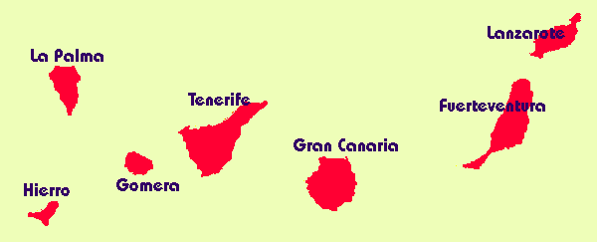

Conversation with a Bi-Lingual, Black Male Educator, Debater, Poet and Philosopher
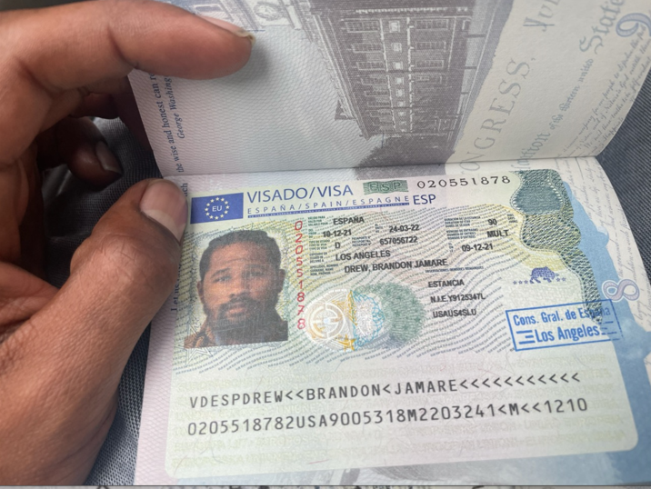
Let us introduce you to Brandon Drew, a native Son of Pittsburgh, now residing on our west coast. A few words to describe him are tenacious, passionate, focused and talented. He is a learner who teaches. Brandon marshals his energy and takes it “on the road” as he travels around the world, always with a purpose.
The interview that follows is a reflection of one of his studious wanderings.
Before we move into our conversation, let’s illuminate some of the thoughts and preparation enlisted for Brandon’s 2021 journey to Spain’s Canary Islands, for perspective. Perspective is provided with authentic snippets of conversation between Brandon and me from September 2021 - December 2021, leading up to his departure for Spain on December 18, 2021.
“I accepted the job in Spain”. 9/14/2021
“Today, I received my placement, in the Canary islands, a Spanish territory, located in Africa.” 9/14/2021
“At the moment, I am researching the Canary Islands [location, demographics, cuisine, etc.] as we speak.” 9/14/2021

“The first steps for relocating to Spain are:
- Waiting for Spain to mail me documentation needed for a visa
- Applying and acquiring said visa. I believe it will take about two months to accumulate a visa for my passport. “9/14/2021

“I am assuming you've heard about the erupting volcano on the island of La Palma in the Spanish Canary Islands. Which island are you assigned to?” [9/22/2021]
“I did. lol.” 9/23/2021

“I will be staying on that very same island. The eruption occurred in the southern hemisphere of the island. The school, however, is located in the northern hemisphere. I am looking for residence in the north western hemisphere of the island. Also, I am thinking of staying on the island of Tenerife which is 45 mins away from La Palma. I am considering taking a ferry to and from work, so I do not have to concern myself with the volcanic eruptions of La Palma. From my understanding that is the only island that has a volcano.” 9/23/2021

“On the videos that I saw, it seemed like the people were happy to see the volcano erupt, but I am from Pittsburgh, we not accustomed to seeing lava oozing from rocks.” 9/23/2021

“I assumed that you would be assigned to La Palma as the capital exists there, correct?, but I had to ask. Glad to know you will be up North or on the isle of Tenerife and, LOL, no you are not accustomed to lava oozing over rocks, sheesh...LOL.
I was in Hawaii when a volcano was oozing. It was crazily interesting but I kept out of the way of the ooze, for sure...LOL” 9/23/2021

“The formation of the Canary islands is uncanny. There are like 8 islands that are divided into like two regions. I believe that the capital or the La Palma you refer to is that of Gran Canaria which is on the eastern hemisphere of the islands. Is considered to be the best island of the eight since it echoes European architecture and has more tourists. For some strange reason they refer to it as La Palma. It is indeed the capital of the islands in the eastern hemisphere.” 9/23/2021

“On the other hand, La Palma, which is located on the western hemisphere with close ties to the Caribbean and the state of Louisiana, where the volcano erupted, is not the capital. The capital of the western islands is Tenerife which is 45 mins away from La Palma by ferry. The culture on this island is Caribbean, from what I read. They even use the same words as Cubans use. For example, in Cuba a bus is referred to as a gua gua, lol. In other Spanish countries, a bus is a bus. In La Palma a bus is a gua gua, lol. I was done when I saw that word on the bus schedule. They even eat Cuban food and most dishes are goat meat, seafood, and, for some strange reason, they have Cuban food, but do not call it Cuban food”. 9/23/2021

“Also, I read that our state of Louisiana has close ties to the Canary Islands as many Canarians relocated to Louisiana while it was under Spanish rule. I ordered a book about said connection to learn more information about it.” 9/23/2021

“Ok, since you now have your ticket you are simply waiting for your Visa. I pray your visa arrives within the week like the random lady said. I don't know if Amsterdam will allow you to TWOV [Transit Without a Visa]. Ultimately, it is the airline that makes the decision as to whether you get on the connecting flight from Amsterdam to Spain. In your preparation for the trip have you heard of the term "Schengen Visa"?? Let me know. If not I will explain.” 12/4/ 2021

“Hi There! I thought you already purchased your ticket from LAX to JFK!? If so, what airline are you using? What airline are you flying to Amsterdam? Is it KLM, the Dutch flag carrier? What carrier [airline] are you taking to MAD? Is it Iberia, the Spanish flag carrier? Let me know the answers to these questions and I will poke around and see if I can be of assistance if you need it. I'll also look into hostels in Tenerife. Will advise.” 12/5/2021

“I postponed the procurement of a ticket from LAX to JFK, keeping in mind: I might not have the visa. I will be flying Delta - New York to Amsterdam to Madrid.
Thanks. Housing is definitely more affordable in Tenerife. I gathered the impression that La Palma is incomparable with the other islands in the archipelago.
I think it may be the most underdeveloped in terms of infrastructure etc. But I don’t mind at all.” 12/5/2021

“Hey B! Check out this link for Hostels in Tenerife!!”

https://www.thebrokebackpacker.com/best-hostels-in-tenerife-spain/
12/6/2021

“Not sure how, but I made it to JFK. I am on my way to Spain, like I am on the plane leaving for France.” 12/18/2021

“CONGRATULATIONS!!! I Pray Traveling Mercy for you. LEARN, GROW, Come Back STRONGER and even more enlightened/edified!! Stay safe. Stay in touch.” 12/19/2021

“At the moment, I am away in Spain working as
an Auxiliar de Conversación with the Canary government in La Palma,
Canary Islands, Spain.”12/26/2021

Legend: CV = CARIBBEAN VILLAGE’S Question
BJD = Brandon’s Answer
And NOW, on to the interview……
[Note: After our conversation, Brandon chose to answer our questions in writing, as presented here]
CV: How did you "land" in Tenerife?

BJD: Since I bought the tickets the day before departing to Europe, my itinerary proved challenging. Actually, I convinced loved ones into buying the tickets for me. To ensure an equitable price, I had to drive, take a few planes, and navigate the Atlantic ocean via ferry to arrive at my destination - La Palma, Spain. So, from Los Angeles, I drove to Las Vegas. Once in Las Vegas, I boarded a plane to Newark, NJ. Then, I caught the metro into New York, where I took a train into JFK. After landing in France, I waited about 7 hours for my flight to Madrid. Once in Madrid, I landed in Tenerife where I ferried to La Palma.

CV: What were your plans and aspirations while there?

BJD: While in Spain, I strove to rehabilitate myself, which led to a reconfiguration of perspective. As a trained Spanish Literary Critic, I desired to experience first-hand the intricacies that configure the Spanish national identity. Put another way, it is inclusive or exclusive.
Prior to departing for Spain, most surmised that it was a racist nation, thereby built on exclusion. While taking SPA 530 Spanish Dialectology, I conducted research on the similarities between the Spanish spoken in Cartagena, Colombia and that spoken in Calí, Colombia, however, there were few [similarities] if any, between the two. To my dismay, the Spanish spoken in Cali resembles that of the Spanish spoken in the Canaries.

CV: What were you looking to accomplish/What did you accomplish?

BJD: I was looking to discover self-awareness. In short, I sought to “know thyself” as prescribed by the oracle in Delphi. However, I unearthed simple truths that awakened my capacity to perceive. Growth sprouts about the island like water from lawn sprinklers.

Therefore, simply put: the aim was to grow bright like the array of fresh vegetables at the PuntaGorda farmers market. Or, maybe, that which I sought was an intimate encounter with nature, its lure; the manner in which its color imitates the pains and pleasures of this life we all live.

Perhaps, my tenure as CEO Barlovento transgressed stereotypical representations of Black men. For example, I was located in an ice cold classroom on the second floor of CEO Barloveonto, Carlos, my supposed supervisor, demanded that I perform work that was outside the parameters of my contract. So, I declined. He became acerbic. Violating his own mandate that I only communicate in English, when I am a fluent Spanish speaker, by conveying to me in Spanish that I was lazy and how I did not want to work; then, he shouted and told me to leave the classroom”. I informed of the following: “ No. I woke up at 4:00am and caught the guagua [bus] for an hour and half to come here for work. So, that is what I am going to do” After, I sat and interviewed my student, who was a Venezuelan immigrant. Simply put: I performed the work as outlined by the contract between myself and the Spanish Ministry of Education (The State). Transgression works wonders.

CV: What "mark" did you leave in that part of our world?

BJD: Actually, before arriving in Tenerife, I fasted for about 24 hours, to be lucid. I missed the plane in Madrid, so I was stranded there for a day. The irony of that anecdote is that later in time I would get stranded in Madrid for two weeks without currency. Anyway, after eating a meal and drinking a cool drink, I walked from the center of Tenerife to the Fred Olsen Ferry station. As I strolled along the boardwalk, some Tenfeños asked me to participate in their video. I replied, of course. The work they requested that I recite was “Overcoming”. So… there you have it. The mark that I left was one of Overcoming.

CV: What language[s] is/are spoken?

BJD: Spanish.

CV: Were you seen and treated as an anomaly or as "another brother"? Please explain.

BJD: An anomaly, not at all. Spanish people treated me better than most of the Americans I have known my entire life. The people there treated better than the people here, especially the Germans. Without Peter, Victor, Adam, and Veronika, I would not have made it through.

CV: Describe the islands in terms of setting.

BJD: The formation of the Canary Islands is uncanny. There are 8 islands that are divided into two regions. I believe that the capital of the La Palma you refer to is that of Gran Canaria which is on the eastern hemisphere of the islands and is considered to be the best island of the eight since it echoes European architecture and has more tourists. For some strange reason they refer to it as La Palma. It is indeed the capital of the islands in the eastern hemisphere.

On the other hand, La Palma, which is located on the western hemisphere with close ties to the Caribbean and the state of Louisiana, where the volcano erupted, is not the capital. The capital of the western islands is Tenerife which is 45 mins away from La Palma by ferry. The culture on this island is Caribbean, from what I read. They even use the same words as Cubans use. For example, in Cuba a bus is referred to as a guagua, lol. In other Spanish countries, a bus is a bus. In La Palma a bus is a guagua, lol. I was done when I saw that word on the bus schedule. They even eat Cuban food and most dishes are goat meat, seafood, and, for some strange reason, they have Cuban food, but do not call it Cuban food.

CV: What did you learn about the connection between the Canary Islands, the Caribbean and the United States?

BJD: I read that our state of Louisiana has close ties to the Canary Islands as many Canarians relocated to Louisiana while it was under Spanish rule. I ordered a book about said connection to learn more information about it.

MANY THANKS to Brandon Drew for sharing his Canary Islands, Spain experience with us!!
GASTRO CARIBE

This monthly segment offers ISLAND recipes, food talk, serving advice and helpful tips.

We always start by defining GASTRONOMY - Gastronomy is the study of the relationship between food and culture, the art of preparing and serving rich or delicate and appetizing food, the cooking styles of particular regions, and the science of good eating.

The National Dish of the Canary Islands
Papas Arrugadas [Wrinkly Potatoes]
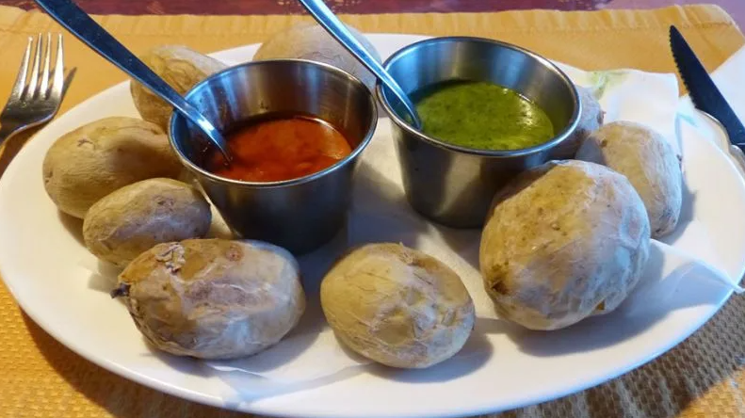
The wrinkly potatoes or Papas Arrugadas, as this authentic dish is called by Canarians, is the archipelago’s most famous dish. Now, one might wonder what can be so special about potatoes?! Today, it’s the sea salt that is used to recreate an authentic taste, however, in the old days, people boiled the potatoes in the naturally salty ocean water. Simple, healthful and delicious!
WHAT YOU NEED:
- 2 pounds of similarly sized small potatoes
- Water
- 4-5 tablespoons of sea salt

WHAT TO DO:
- Wash the potatoes well and scrub off all the dirt but don’t peel them. Leaving the skin on is crucial for making Canarian potatoes, this way they can achieve their typical wrinkly look.
- Add just enough cold water to cover the potatoes and add the salt.
- Bring to a boil and allow to boil for 15-20minutes, depending on their size, until the tip of a sharp knife pierces the skin easily. If during this time the water level drops a lot, add more hot water to the pot.
- Drain the potatoes and leave them in the pot to dry. When the water evaporates the potatoes will become wrinkly from the salt and you will see a faint salt layer on the skin.
- Serve the Papas Arrugadas with the typical Canarian mojo [sauces]: mojo picon [red] and mojo verde [green].
Now, for the Mojos…..
WHAT YOU NEED for Mojo Picon:
- 1 head of garlic
- 2-4 red chili peppers
- 1 bell pepper
- 5 tablespoons of olive oil
- 2 tablespoons of wine vinegar
- 1 teaspoon ground cumin
- Salt to taste
WHAT TO DO:
Prepare the sauce with a mortar and pestle or with a blender.
- Make a paste in the mortar from the garlic cloves, peppers, cumin and salt.
- Then slowly add the wine vinegar and olive oil until it transforms into a sauce that has the consistency of a paste.
- If preferred, to make the sauce thicker you can do as the Canarians by adding crusty bread to the mixture, just enough to thicken.
This mojo brings the HEAT!!!

WHAT YOU NEED for Mojo Verde:
- 4-5 cloves of garlic
- 1 green pepper
- 4 tablespoons of olive oil

WHAT YOU NEED for Mojo Verde [continued]:
- 2 tablespoons of wine vinegar
- 1 teaspoon ground cumin
- 1 bunch of cilantro or parsley
- Salt to taste
WHAT TO DO:
- As with the red Mojo Picon, use a mortar and pestle or a blender to make a paste from the garlic, green pepper, cumin, cilantro [or parsley]
- Then slowly add the wine vinegar and olive oil until it transforms into a sauce that has the consistency of a paste. Mix well.
This mojo is green and flavorful!!!
Canarian mojo sauces are also served with fried fish, pork or just with bread, as a starter.

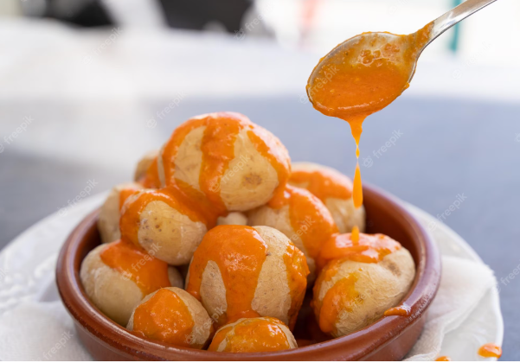
Try this AUTHENTIC Canarian Recipe!!!

Book of the MONTH


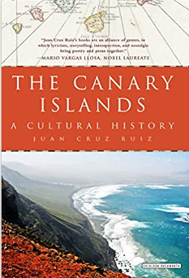
Traditional guidebooks give straightforward advice on what to do and where to go, but in this remarkable cultural history, celebrated journalist and Canary Islands native Juan Cruz Ruiz offers something much more―a fusion of literature and travel that will captivate both globetrotters and interested readers looking for a more intimate exploration of this rich archipelago, which is part of Spain, yet completely distinct from the mainland.
This work weaves together lectures, memories, and experiences. The author Ruiz explores the geography, the food, the local art of the Canaries and tells the stories of the Canarian people.
~ A MUST READ to prepare to travel ~

To Find this Book, GO TO:
www.Amazon.com
SEARCH The Canary Islands: A Cultural History by Juan Ruiz
OR…..Visit your local Library

Scenes from each of the Canary Islands
Tenerife

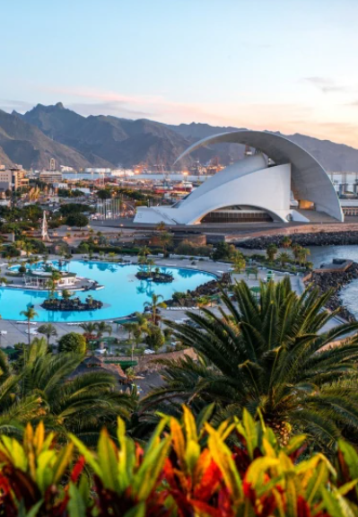
The Tenerife Auditorium – Auditorio de Tenerife
Modern Architecture

Scenes from each of the Canary Islands
La Palma
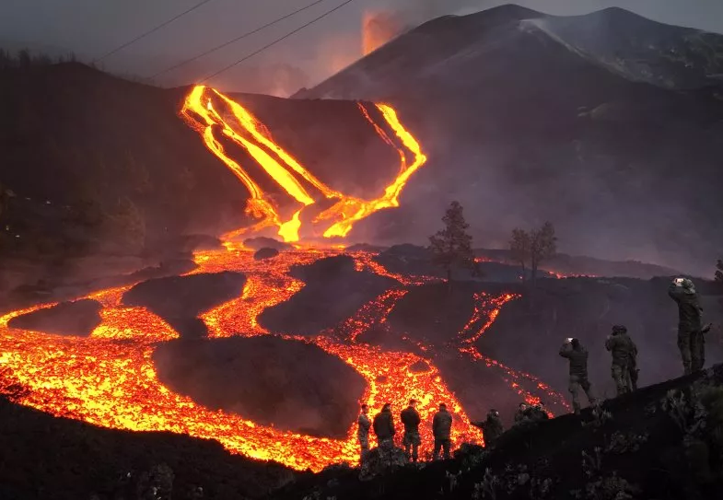
Spanish soldiers stand on a hill as lava flows on La Palma on November 29, 2021. The Cumbre Vieja volcano started erupting on September 19, causing widespread destruction. For months, lava ran across the island, destroying thousands of buildings and devastating roads and farmland. The eruption marked the longest on record for La Palma and destroyed some 3,000 properties across 3,000 acres.
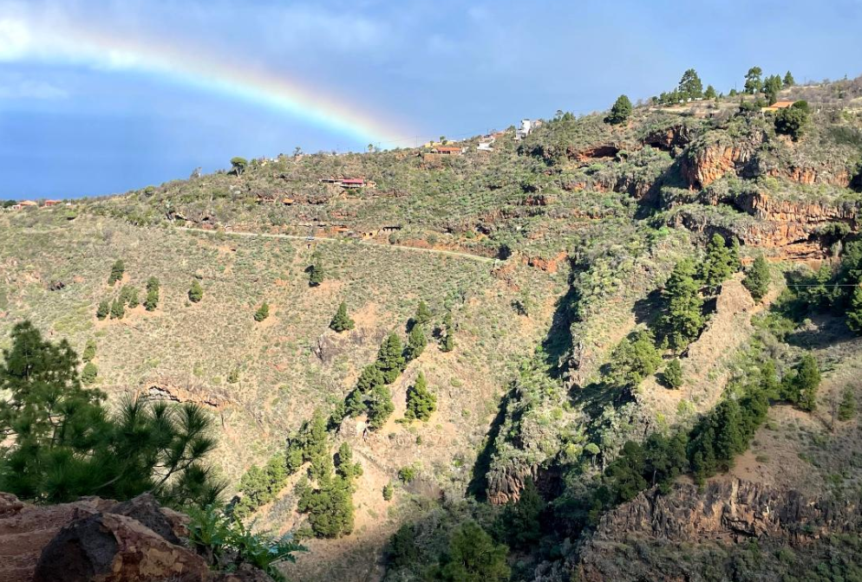
Rainbow over mountainous terrain in La Palma

Scenes from each of the Canary Islands
Gran Canaria
Bufadero de la Garita

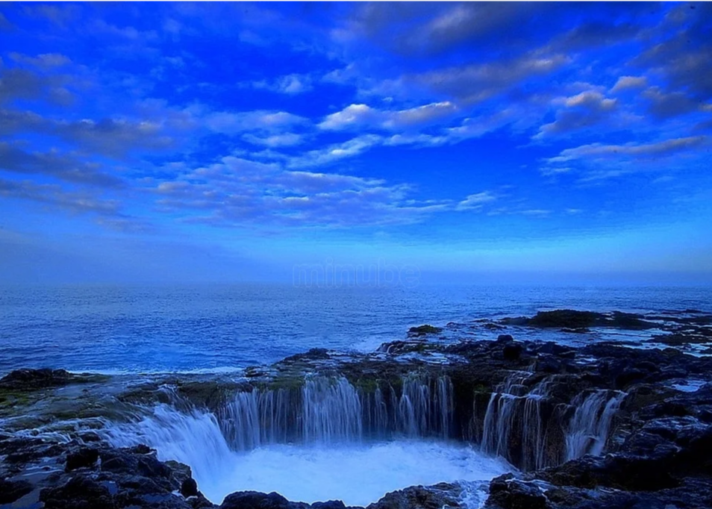
There are two big cavities in the rocks from which the water flows filling them and emptying them at breakneck speed. Just in case you are asking yourself why it’s called “bufadero”. It is very simple: the rocks themselves have cavities in their interior, so when the tide goes up and fills them, these holes “spurt” the water while making a very characteristic sound, as if they were snorting (“bufando”, in Spanish).
It is quite a spectacle that is worth seeing, but you have to be careful since many people have drowned by going inside. You are literally at the mercy of the tide.

Scenes from each of the Canary Islands
Hierro
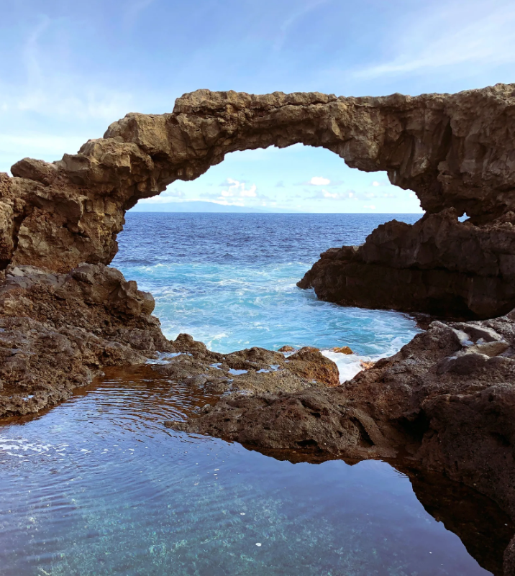

Scenes from each of the Canary Islands
Gomera

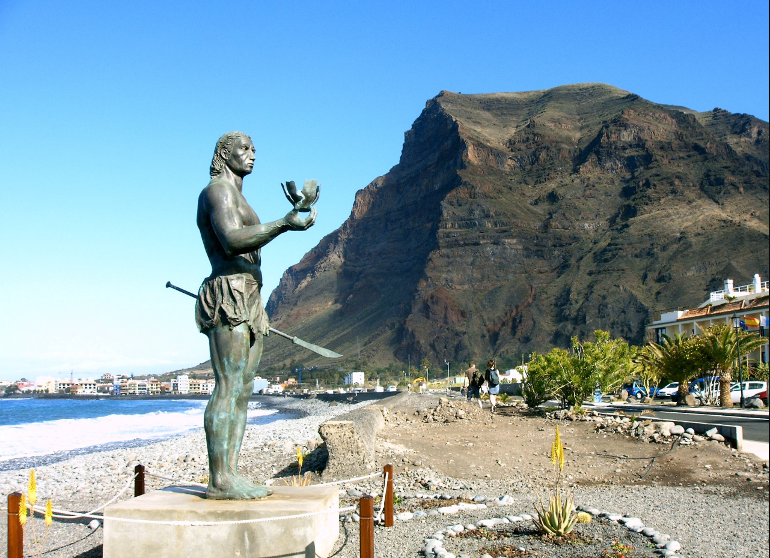

Statue of Guanche warrior at La Gomera, Canary Islands, Spain

The original inhabitants of the Canary Islands are commonly known as Guanches.
They are believed to be related to the Berber peoples of northern Africa.
The Guanches were the only native people known to have lived in the Macaronesian archipelago region before the arrival of Europeans.

Scenes from each of the Canary Islands
Lanzarote

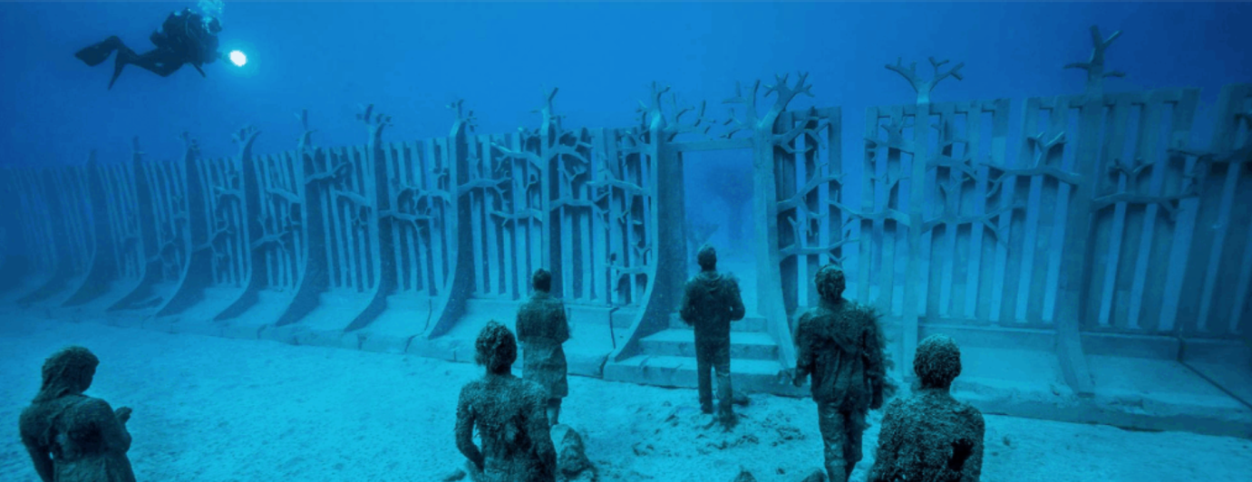
At a depth of 39 feet in the Bahía de Las Coloradas, in the south of the island lies what is known around the world as the Atlantic Museum.

Submerged in the Atlantic Ocean there are three hundred human statues. These creations bring life to the sea of Lanzarote and comprise the third underwater museum designed by the British artist Jason deCaires Taylor.
The author’s aim with this work was simply to represent the union that has always existed between the Canaries and the sea. To do so, the molds for each of the statues under the sea of Lanzarote were created using the molds of residents from the nearby area.
But that is not all. The sculptures under the sea of Lanzarote were also created to contribute to the development of coral reefs that will end up fusing the creations with nature. Hence, the union between the sea and the island-dwellers.

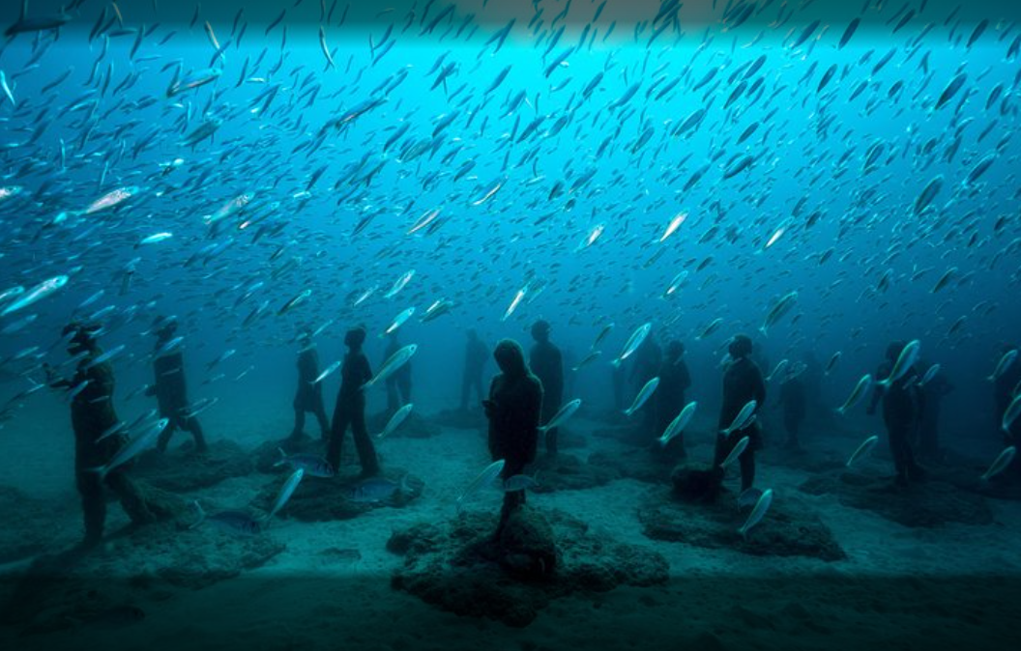
Scenes from each of the Canary Islands

Fuerteventura

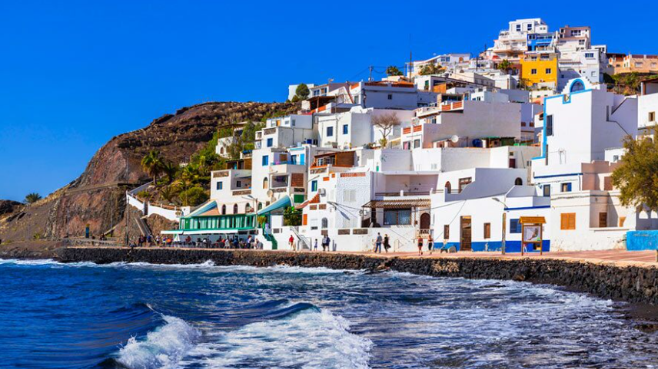
Caleta de Fuste: a family favorite found within the municipality of Antigua, is located in a tourist resort of outstanding natural beauty in central Fuerteventura. This town is famous for its peaceful beach with barely any waves, perfect for families looking for a relaxing day out.

VEXILLOLOGY

…The Study of FLAGS…
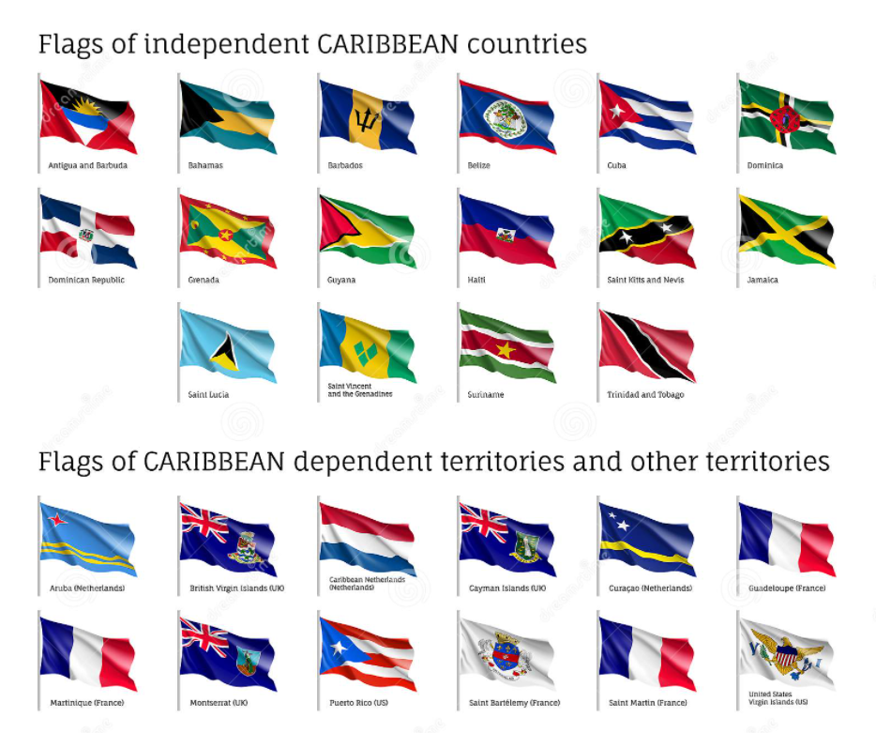

Where in the World are the Canaries?

Where in the World? - is a new segment in the CULTURE-ZINE starting with our 2nd Volume. The purpose is to point out where the Caribbean territories and interests are located in our WORLD.
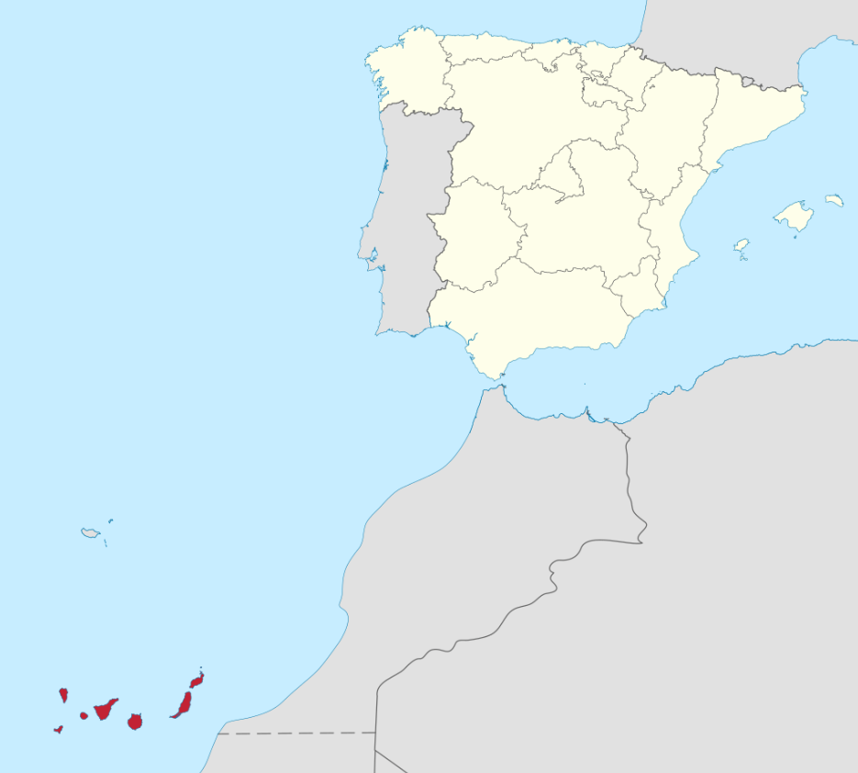
See the red islands situated off the northwest coast of Africa?? You can also see the closeness of Spain [top] to Africa. Politically the Canary Islands are part of Spain, however, they are closer to Africa than they are to Europe and so geographically they are part of the African continent.

COME VISIT
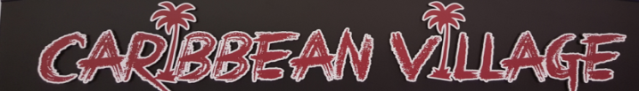
At
Monroeville Mall
Monroeville, PA, 15146
Suite 100B-1
1st Floor, Near MACY’S
412-377-7951
Business Hours
Monday – Thursday 11AM – 8PM
Friday – Saturday 11AM – 9PM
Sunday 12PM – 6PM

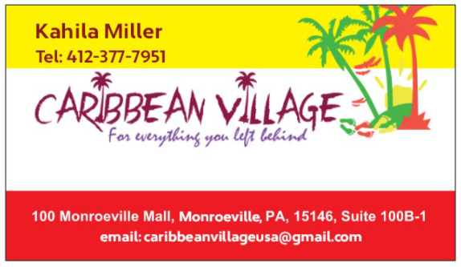

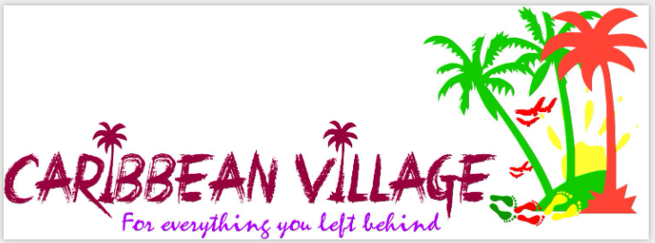

During January & February 2023, we are offering 10% OFF of SELECT ITEMS!!!

[Check with store management]
- This Discount is Not Valid with any other offer.
- One qualifying discount is available per customer.

Remember, you can now visit, browse and communicate with “The VILLAGE” via www.caribbeanvillageusa.com. We want to HEAR FROM YOU!!

Building STRONG Business Communities through ADVERTISING

SPREAD THE WORD ABOUT YOUR BUSINESS
Greetings! We extend an invitation to Advertise with CARIBBEAN VILLAGE via our monthly online publication called, "The CARIBBEAN VILLAGE Insider CULTURE-ZINE".
The CULTURE-ZINE is an online E-Zine purposed to:
- Focus on the "intra-diversity" of Caribbean Culture
- Showcase the whole of the Caribbean, not just a few often visited locations, and
- BUILD STRONG BUSINESS COMMUNITIES by supporting one another through marketing, advertising and promotion

We want to spread the word about YOUR business locally, nationally and/or internationally.
Does your business need an app or a mini site?? Let US do it for you, AFFORDABLY!!

Why spend thousands to do what this ad is doing with the integration of video, text links, forwards and so much more?!?!
Let us create an ad for YOU!!

We create….

- Profile Pages
- Mini Sites
- Full Landing Pages with ecommerce, for 1/3 the cost of a full website
- And it's all Mobile Friendly

Best of all, it's shareable to all social networks and emails via a link, plus a QR code image for easy customer access. Imagine all of your relevant information in one place. And you don't need a domain name or expensive hosting. Your page can be hosted with us or we can link your existing domain to your mini-site. How efficient is that?

Building STRONG Business Communities through ADVERTISING

Whatever your business, Whatever the event, Let US take your business promotion and interactivity to the NEXT LEVEL

name or expensive hosting. Your page can be hosted with us or we can link your existing domain to your mini-site. How efficient is that?

Whatever your business, Whatever the event, Let US take your business promotion and interactivity to the NEXT LEVEL.

You can even sell directly from your profile via PayPal or Stripe – Yes, the effectiveness of ecommerce!

Click this link >>>
Click the link below https://app.linkable.studio/3rdEyeStudios/3rdEyeServices

And, that’s how simple, diverse and efficient PROMOTING your business or product can be when you ADVERTISE with BattlePlan Virtual and Third Eye Productions!!

Call us on “WhatsApp” NOW for more information - +1 268-773-5264

ADVERTISE WITH US!!

Canary Islands Flag Youth Coloring Page
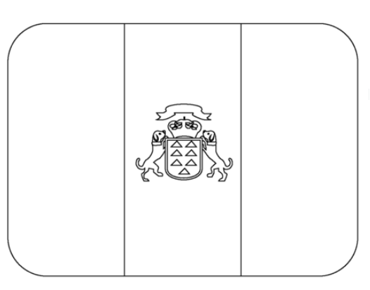
The flag is a vertical tri-color of three equal bands of white, blue, and yellow.
WHITE on the left corresponds to Tenerife’s western location. YELLOW on the right corresponds to the eastern location of Gran Canaria. BLUE, in the middle is the common color.

Volume 1 of The CARIBBEAN VILLAGE Insider Newsletters and CULTURE-ZINE
Issue 1: 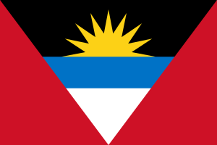Antigua and Barbuda November 2021
Issue 2: 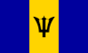Barbados December 2021
Issue 3: 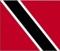Trinidad and Tobago January 2022
Issue 4: 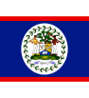Belize February 2022
Issue 5: Guyana March 2022
Issue 6: 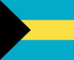The Bahamas April 2022
Issue 7: 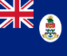Cayman May 2022**
Issue 8: 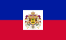Haiti June 2022**
Issue 9: U.S.V.I. July 2022**
Issue 10: St. Kitts and Nevis August 2022
Issue 11: St. Vincent/Grenadines September 2022
Issue 12: 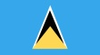St. Lucia October 2022
** These issues are accessible to view via the www.caribbeanvillageusa.com website. Click CULTURE-ZINE, Move down to the BOOKCASE, Click the cover image!!

Volume 2 of The CARIBBEAN VILLAGE Insider CULTURE-ZINE
Issue 1: 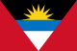Antigua & Barbuda November 2022
- 41st Antiguan Independence Celebration Issue
Issue 2: 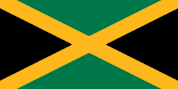Jamaica December 2022
Issue 3: 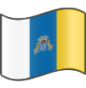 Canary Islands, Spain January 2023
- This issue explores the connection between Spain’s Canary Islands, the U.S. State of Louisiana and the Caribbean.

The CARIBBEAN VILLAGE Insider CULTURE-ZINE
Volume 2, Issue 3, January 2023

This E-Zine is Created, Curated and Produced By

www.battleplanvirtual.com
For CARIBBEAN VILLAGE, Monroeville Mall, Monroeville, PA, 15146

PLEASE feel free to SHARE this publication WITH YOUR NETWORK

CONTACT CARIBBEAN VILLAGE AT 412 377 7951 or 412 805 9687 to PURCHASE A PAPER COPY of this CULTURE-ZINE

