The  Insider
A “CULTURE-ZINE”
Volume 1, Issue 3, January 2022

Patrons and Friends……
~HAPPY NEW YEAR 2022~
It’s a New Year and we hope our first 2 editions captured your attention to a point that encourages you to stay with us as we explore issues that interest and edify you in 2022. As we state in each issue of The Insider, our objective is to educate, inspire and entertain our readers as we present content that is of interest to:
- The Caribbean diaspora, in particular, as well as,
- A multi-cultural diaspora, and also
- The Caribbean Enthusiast - anyone who is interested in the Caribbean Experience
Soooo, Let’s get this New Year Started!!!

The FOUNDER’s Notes
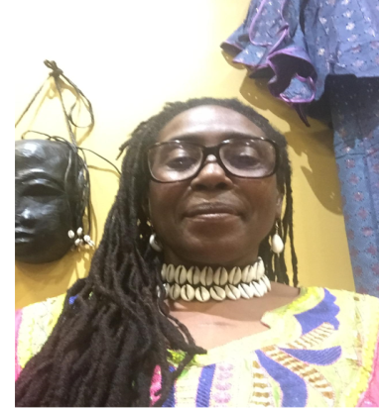
Greetings Friends!! I hope you enjoyed the first 2 issues of The Insider!!
This month another set of Sister Islands is featured - Trinidad and Tobago!! Inside expect to read one of two enlightening interviews with Consul General J. Andre Laveau, The New York based Consulate General of the Republic of Trinidad and Tobago. The second interview will appear in the February 2022 issue. There is also an interview with local Tobagonian, Verna Crichlow.
READ ON for inspired offerings of Caribbean Culture including News, Interviews, Recipes and other edifying tidbits! ENJOY!
Table of Contents
Volume 1, Issue 3, January 2022

Page 1: Introduction and The Founder’s Notes
Page 2: Table of Contents
Page 3: The Flag and Coat of Arms of Trinidad and Tobago
Page 4: A Conversation with Trinidad and Tobago Consul General J. Andre Laveau
Interviewer: Keywanda Battle
Page 10: A Tobagonian in Pittsburgh – Verna Crichlow
Interviewer: Keywanda Battle
Page 13: Gastro Caribe
Page 17: Kahila’s Taste
Page 18: WHY CARIBBEAN HISTORY MATTERS By Lillian Guerra
Page 20: Book of the Month
Page 21: Caribbean News

Page 24: VEXILLOLOGY: FLAGS of the CARIBBEAN NATIONS
Page 25: PRODUCER Information Page [Last Page]

In this Newsletter, where you see ………… , the dots indicate there is MORE to Read and Learn and a LINK is provided.

The FLAG and Coat of Arms of TRINIDAD & TOBAGO

The flag of Trinidad and Tobago was adopted upon independence from the United Kingdom on August 31,1962. The colors represent as follows:
RED – The Sun, symbolizes Courage
BLACK – The Earth symbolizes Dedication
WHITE –The Water symbolizes Purity and Equality

The flag was designed by Carlisle Chang.

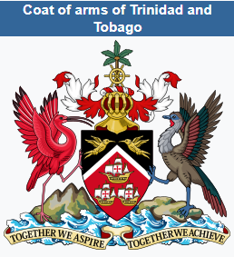
The palm tree crest at the top of the coat of arms was taken from Tobago's coat of arms before it was joined in political union with Trinidad. The shield is comprised of the same colors (black, red, and white) as the nation’s flag and carries the same meaning. The gold ships represent the three ships Christopher Columbus used on his voyage. The two birds on the shield are hummingbirds. Trinidad is sometimes referred to as the “Land of the Hummingbird” because 18 different species of hummingbird have been recorded on the island. “Land of the Hummingbird” is also believed to have been the Amerindian name for Trinidad. The two larger birds are the Scarlet Ibis (left) and the Cocrico (right), the national birds of Trinidad and Tobago. Below the Scarlet Ibis are three hills, representing the Trinity Hills in southern Trinidad, which, it is believed, convinced Columbus to name the island after the Holy Trinity. The island rising out of the waters beneath the Cocrico represents Tobago. Below these birds is the nation's motto, "Together We Aspire, Together We Achieve."
The Coat of Arms was designed by Carlyle Chang Kezia and George Bailey.
A Conversation With The Consul General of TRINIDAD & TOBAGO
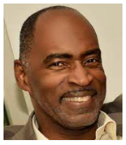
~ J. Andre Laveau ~
First, The CARIBBEAN VILLAGE Insider THANKS Consul General Laveau for taking time out of his busy schedule to honor us with his time, knowledge, expertise and perspective regarding his native country. CG Laveau’s office is located in downtown Manhattan, New York City.
The goal of the interviews presented in The CARIBBEAN VILLAGE Insider Newsletter is three faceted:
- We aim to edify our readers with informative, useful, little known and perhaps, unsung or undiscovered information about the featured island nations. We hope to answer questions you may have about the native people, locale, customs, political system of the country and the historical perspective from the viewpoint of the interviewee.
- We aim to delight our readers who are natives of the featured islands and bring pleasant memories of HOME.
- We aim to imbue a curiosity in the reader - to want to learn more about the island and its people.
>>We encourage you to support the Islands by VISITING!!!<<
Now, on to the Interview with Consul General Laveau………..

CV = CARIBBEAN VILLAGE Question, in red text
CG = Consul General Laveau’s Answer
CV: What is the population and location of your country?
CG Laveau:
“The Population of Trinidad and Tobago is approximately 1,400,000. There may be as many as 500,000 Trinidad and Tobago Nationals in the Diaspora, living away from the homeland, in North America, the United Kingdom and Europe, the Caribbean, Africa Asia and elsewhere. We have a very diverse population. It is about 35% African and 35% Indian. However, the fastest growing group is the mixed group, which is now almost 20%. The rest of the population is mainly European, Chinese and Syrian-Lebanese. Among member countries of CARICOM, which is the English speaking regional grouping of the Caribbean, only Jamaica has a larger population.
Regarding our location, our specific GPS coordinates are:
10° 2' and 11° 12' N latitude and 60° 30' and 61° 56' W longitude, with the Caribbean Sea to the north, the Atlantic Ocean to the east and south. We are the most southerly islands in the Caribbean. We are at the bottom of the Caribbean archipelago. Our closest neighbor is Venezuela, within 7-8 miles from our shore. To the north, our closest neighbors are Grenada and St Vincent and the Grenadines.”

CV: In which part of your country do most people reside?, or is the population dispersed throughout the country?
CG Laveau:
“A good estimate would be that approximately 600,000 people live in what is known as the East-West Corridor of Trinidad. This area, in the North of the island, includes the capital city: Port of Spain. Port of Spain has an urban population of nearly 100,000. Because of the level of economic activity and the location of goods and services, Port of Spain’s daily population swells to about 540,000. It is both the political and economic capital and hub of the island. One may say it is the cultural capital as well. Other major population hubs are: San Fernando, the second largest city and the Borough of Arima in the East. In Tobago, where the main city/administrative center is Scarborough, the population is about 63,000.”

CV: What is the political System in Trinidad and Tobago? Are there governance differences between the 2 islands?
CG Laveau:
“Trinidad and Tobago became independent in 1962. In 1976 final vestiges of the rulership of the British Crown were shed and the country became a twin-island Republic.
The President of the Republic of Trinidad and Tobago therefore, became the Head of State, having mainly ceremonial powers.
The Prime Minister is the lead executive of the Government.
There is a Parliament consisting of an Upper House - the Senate, and a Lower House - the House of Representatives. The Parliament is vital to our governance and an exemplification of free speech - a most vital element of our democracy.
The Republic inherited a governmental system that closely resembles the British system, having a separation of powers into 3 branches – Legislative, Executive and Judiciary.
In 1980 Tobago acquired its own House of Assembly”
CV: What can you say about the leaders of your country?
CG Laveau:
“We are proud to say that we have one of just 21 female Heads of State or Government in the world. She is Her Excellency, Paula-Mae Weekes. Our Prime Minister, Dr., The Honourable Keith Rowley, has been PM – Chief executive of the Government, since September 2015.”
CV: Is your country dealing with a financial crisis right now?
CG Laveau:
“Naturally, with the global slowdown due to the pandemic, there would be a deterioration in the balance of trade stemming mainly from the decline in energy exports. However, our balance of payments remains stable. There have been no banking failures. We have more than nine months of available resources to cover imports, so we are in a good position. Additionally, COVID-19 restrictions constrained the development of some important energy projects. Nevertheless, our macroeconomic outlook is now brighter, as oil and gas prices have recovered significantly from their recent low levels.”
CV: How is the COVID-19 Pandemic affecting Trinidad and Tobago?
CG Laveau:
“We have had many COVID-19 cases, as most of the Caribbean region has had, and have had many deaths, but through strong leadership and enforcement of regulations and protocols, we are coping with the situation. A series of measures have been put in place to help stop the spread. Measures are also in place to mitigate the effects on the citizenry, such as food grants, emergency hampers, fuel relief etc.”
CV: What is the most popular sport in the country? Are there any sports or games that are unique to Trinidad and Tobago?
CV Laveau:
“Soccer and Cricket are the most popular sports nationally.
We also, very proudly, have Indigenous Sports, such as GOAT RACING in Tobago and KALENDA or Stick Fight, in Trinidad. In Goat Racing, the goat’s owner has to be fast, because he runs alongside the goat in the race. Goat racing is a real spectacle to watch: very upbeat and entertaining. To witness this sport is absolutely worth a trip to our Beautiful Tobago!! AND, let us not forget our peculiar Crab Racing!!
Kalenda is West African “sport theater” that found its way to our islands during colonialism. The stick fight is fought to the sound of African drums beating in the background. Very Exciting!! The winner is the first fighter to draw blood. Also, worth a visit to our country to experience!!
Both of these Indigenous Sports are unique to our country.”
CV: What languages are spoken in your country?
CG Laveau:
“We speak English with a very interesting accent and melodic lilt. People tell us we sing when we speak. Our diverse history has really served to enrich the language with all kinds of expressions. Other languages you will hear include a variant of Hindi from the Indian influence, Yoruba from the African Influence, as well as, of course, Spanish and French. You can also find certain regions and linguistically curious people speaking a rich French patois, resembling that spoken in St. Lucia and Dominica.”
CV: What are the principal economic activities of Trinidad and Tobago?
CG Laveau:
“Our principal economic activities are based on the production oil and natural gas. We have significant resources of oil and natural gas both, on and off-shore. These resources are leveraged to expand manufacturing in our petrochemical industry [lubricants, urea, methanol etc.] and to feed other light and heavy manufacturing.
Regarding environmental impacts, we have been quite well applauded for our efforts to maintain environmental balance. In fact, we have a nature reserve situated amidst an oil refinery which is called the Wild Fowl Trust. This rare curiosity is something to see and experience when you visit.”
CV: What is Trinidad and Tobago’s most celebrated holiday and how is it commemorated?
CG Laveau:
“Our world renowned CARNIVAL is our most celebrated annual event. The celebration occurs for 2 days, once a year but it is an entire season of festivity, starting with the dawn of the New Year and ending on Carnival Tuesday [the day before Ash Wednesday]. Carnival is a famously bold presentation of creativity that includes music, choreography, artistry, costuming and island-wide pride!! Calypso music was born in Trinidad, as was the only acoustical musical instrument invented in the last century – Steel Pan. Steel Pan is Trinidad and Tobago’s GIFT to the World!!”
CV: What does the Consul General’s job entail? What are the responsibilities?
CG Laveau:
“As Consul General I provide strategic direction to our mandate to deepen relations between Trinidad and Tobago and the cities and states in the jurisdiction of our assignment [New York City/East Coast States]. The Consul General directs the relevant aspects of Trinidad and Tobago’s foreign policy into his Mission, in the host country, by performing the following duties:
- providing professional and technical leadership
- spearheading initiatives for public outreach and public information
- providing oversight for quality assurance with respect to Services for his country’s nationals, including passports and vital certificates
- promoting investment, trade, tourism, technical cooperation, educational cooperation, cultural cooperation within the host country”

>>In the NEXT ISSUE, LOOK FOR Consul General Laveau’s historical perspective of Trinidad and Tobago<<

A TOBAGONIAN in Pittsburgh
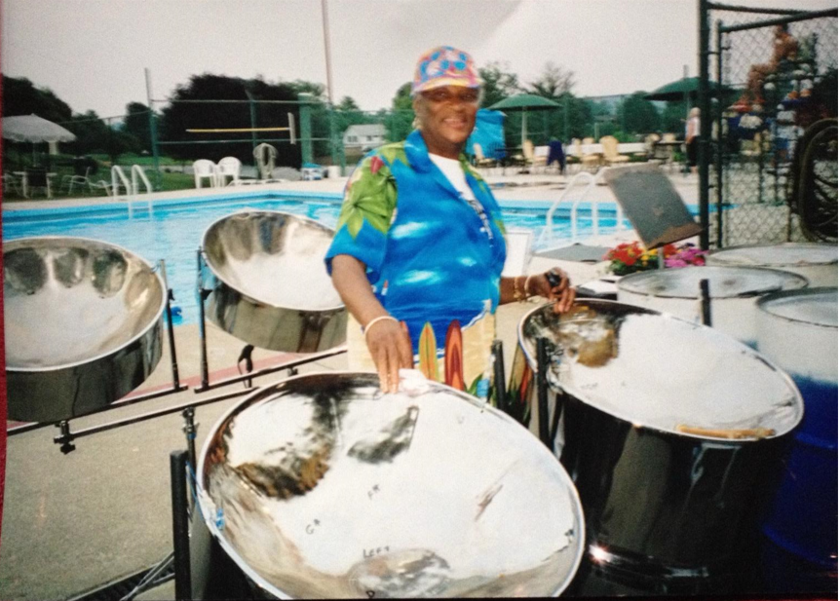
CARIBBEAN VILLAGE was honored with the opportunity to have a meaningful and revealing conversation with Tobagonian, VERNA CRICHLOW. Ms. Crichlow is a long time Pittsburgh resident. She emigrated from Tobago to Pittsburgh with her husband in 1964. They created a family that includes 5 children who were successfully raised right here in Pittsburgh and college educated while she taught Mathematics for the Woodland Hills school district.
Verna Crichlow is a leader in the community. She has contributed much to Pittsburgh’s Cultural Scene and to the Pittsburgh community-at-large. Awareness of Caribbean culture increased in Pittsburgh as a result of her work and volunteerism as noted below:
- Through her mere presence in the Woodland Hills School District as a Mathematics Teacher
- As owner and Director of The Caribbean Vibes Steel Band, Ms. Crichlow taught percussionists how to play the steel drums. Her band has performed at The August Wilson Center, The Pittsburgh Arts Festival, Holy Cross Episcopal Church, weddings, even a funeral convention and a host of other events over the years and throughout the area. Ms. Crichlow says, "although I am slowing down, I am not ready to give up yet”
- As a volunteer at Radio Station, WYEP 91.3, performing as the DJ for “Caribbean Rhythms” and “Voice of the Islands”, presenting Pittsburgh with Caribbean music, African music and World Beats. She transitioned into the role of DJ at WYEP following her mentor, Chris Noel.
- As a volunteer for Global Pittsburgh with the Pittsburgh Council of International Visitors
- As a Sunday school teacher at her beloved Holy Cross Episcopal Church
- As a volunteer at the Hillman Cancer Center, and,
- As an organizer with the Functional Literacy Ministry of Haiti [FLM] Annual Walk-A-Thon
Crichlow’s volunteerism provided visibility for our local Caribbean Community and made us Proud!!
When we discussed the question of association[s] in Pittsburgh that promote Trinidadian and Tobagonian culture it was revealed that the Caribbean Association of Pittsburgh used to exist to promote all Caribbean culture but that organization has fizzled out.
The community now needs someone to take up that banner and adopt that purpose! Will it be YOU?
As we discussed holidays and celebrations in Trinidad and Tobago it was edifying and interesting to learn that Tobago’s annual HARVEST celebration is as popular and heartfelt to Tobagonians as Trinidad’s annual CARNIVAL celebration is to Trinidadians.
Tobago’s HARVEST celebration has a “Gastronomical Feast” theme that is similar to Pittsburgh’s FESTIVAL GASTRO CARIBE produced annually by Kahila Miller’s CARIBBEAN VILLAGE.
The “teacher” in Verna Crichlow exerted itself as she answered a question about the correct terms to use to refer to natives of the Sister Islands – Trinidad and Tobago. Those who are from Tobago are referred to as “Tobagonian”. Those who are from Trinidad are referred to as “Trinidadian”. The term that refers to all who are from the Sister Islands is “Trinbagonian”. Enlightening!
From our conversation it was evident that Ms. Crichlow remains connected to her homeland in heart and spirit. Although she resides in Pittsburgh she is knowledgeable about and cares about the current politics of her country. However, that is a different conversation to occur at another time but CARIBBEAN VILLAGE would be honored!!
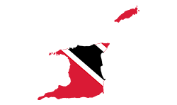
GASTRO CARIBE
This monthly segment offers ISLAND recipes, food talk, serving advice and helpful tips.
Let’s start by defining GASTRONOMY - Gastronomy is the study of the relationship between food and culture, the art of preparing and serving rich or delicate and appetizing food, the cooking styles of particular regions, and the science of good eating.
Crab and Callaloo is the National Dish of Trinidad and Tobago, where it is traditionally enjoyed for Sunday lunch.
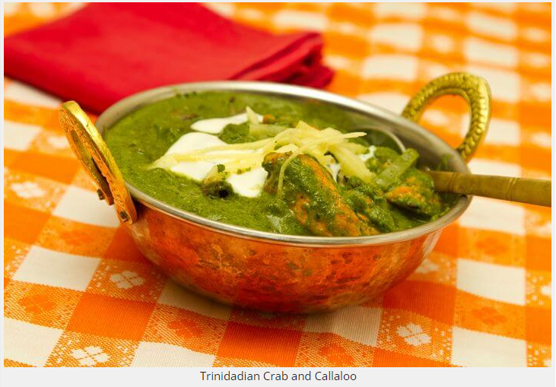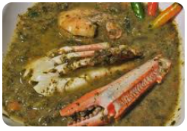
Juicy, tender crab meat is simmered with callaloo (dasheen) leaves in a creamy and flavorful coconut sauce to make the popular Trinidadian dish, crab and callaloo. The distinctive sauce has coconut milk at its base, with a robust blend of onion, okra, spices, and hot pepper. This dish goes well with rice but may be paired with just about any other Trinidadian side dishes. Some choose to make crab and callaloo very thick, while others prefer to make it as thin as soup- whichever way you like it, this recipe is a great starting point.
Adapted from Simply Trini Cooking

WHAT YOU NEED:
- 1 bundle dasheen leaves (approximately 12 leaves), stalks removed and finely chopped
- 7 small pods okra, finely chopped
- 2 tbsp. salted butter
- ¼ cup finely chopped onion
- 4 pimentos, finely chopped
- 3 cups water
- 1 small crab or 1 large gundy (crab claw), cleaned and chopped into 1″ pieces
- 1 green hot pepper, whole, optional
- 1 cup coconut milk
- 2 sprigs thyme, finely chopped
- 4 chives, finely chopped
- 1 bouillon cube, optional
- Salt and pepper, to taste

WHAT TO DO:
- Combine all ingredients except for the hot pepper and salt in a large saucepan over medium heat. Bring to a simmer and cook for about 15 minutes, stirring occasionally.
- Add the hot pepper and salt to taste.
- Cover the pan and continue to simmer for about 15 minutes, until everything is tender.
- Remove the hot pepper and crab pieces with a slotted spoon and set aside. Transfer the remaining contents to a blender and blend until smooth.
- Return the blended sauce, crab, and hot pepper to the pot.
- Serve hot with rice. ENJOY!!

CALLALOO
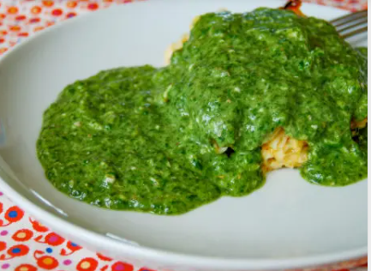

Tobago's Signature Dish is Curried Crab and Dumplings – when Trinidadians mention their sister isle, they'll talk about the quiet life, the relaxed beaches, and argue about where to get the best Crab 'n' Dumplin'. This dish is truly Tobagonian through and through – a bit messy to eat but your taste buds will totally Thank You!

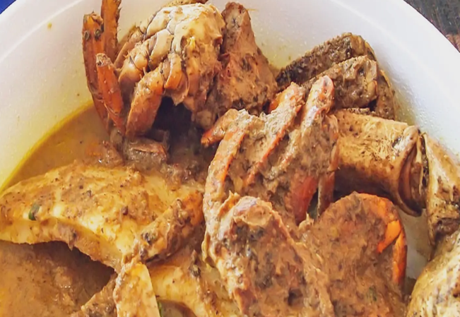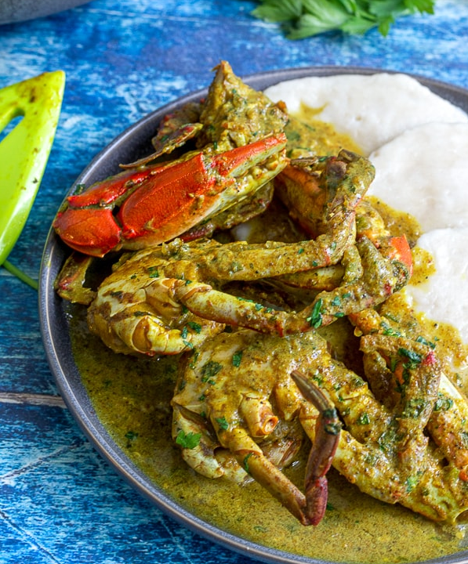

WHAT YOU NEED:

- 4 Large Crabs [Caribbean Blue Crab if possible] [see page 10]
- 4 tbsp. Margarine
- ½ cup Chopped Onion
- 1 tsp Minced Garlic
- 1 tbsp. Green Seasoning
- ½ tsp Fresh Ginger
- 2 tbsp. Curry Powder
- 1 cup Coconut Milk
- ½ cup Water [for crab mixture]
- 1 cup Flour
- 1 tsp Baking Powder
- ½ tsp Salt
- ½ cup water [for dumplings]
WHAT TO DO:
- Start by cleaning the crab and cutting it into sections.
- In a medium pot, at medium heat, heat the margarine. Add onion, garlic, ginger, and green seasoning. Cook until onion becomes translucent.
- Add the curry. Add the coconut milk. Simmer for 1 minute.
- Add the crab and water. Salt and pepper to taste. Bring to boil and cook for 5 minutes.
- For the dumplings, combine flour, baking powder and salt in a large bowl.
- Stir in water. The dough should be soft enough to drop from a spoon.
- Pick out small bits of dough and roll finger-sized dumplings in the palm of your hand.
- Drop the dumplings in one at a time as you get them done.
- Cover tightly, reduce heat and cook for 25-30 minutes. Add more water, if needed.
- Serve and ENJOY!!

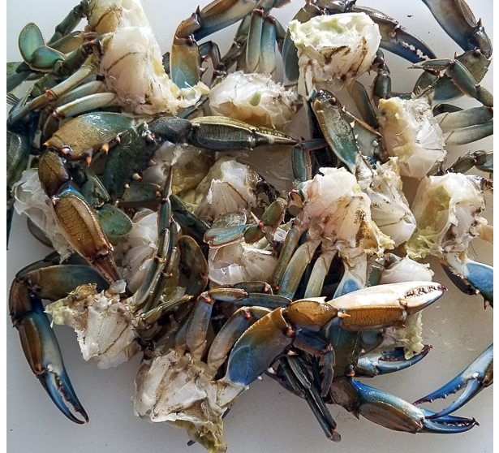
Caribbean Blue Crab

Kahila’s Taste
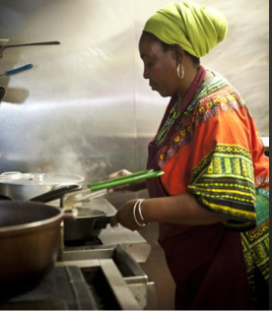
This month, our Founder, Chef Kahila, offers a Tasty Deal for NUTRITION-ON-THE-GO!! A Great LUNCH DEAL, a Filling mid-day Snack!
It’s a “lick finger ting”!!!!
Sooo, Would you like to know………
HOW TO EAT A PATTY WITH COCO BREAD???
Well, you take the hot patty and put it in the Coco Bread to cool it down and eat it as a sandwich… or… add a piece of cheese… or… add lettuce and tomato and, ENJOY!
You will be full up and satisfied!!

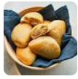

WHY CARIBBEAN HISTORY MATTERS by Lillian Guerra
Lillian Guerra is professor of Cuban and Caribbean history and director of the Cuba program at the Center for Latin American Studies at the University of Florida.
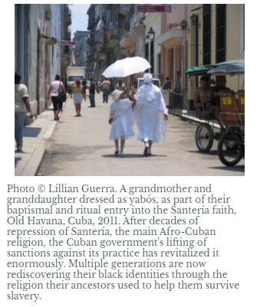
Over the years, I have had dozens of conversations on the question of whether Caribbean history “really matters” and for whom it matters. I’ve heard the region’s history dismissed due to the relative size of Caribbean societies, historians’ supposedly excessive preoccupation with slavery, and a questioning of what lessons can be learned from such allegedly dysfunctional societies.
One particularly memorable encounter took place at a fund-raising event for Haiti. Swirling his cocktail, a surgeon asked if I could explain the “erratic behavior” of the Haitians who greeted him when his US medical team arrived at a temporary field hospital after the 2010 earthquake.
Much of the Haitian staff, he remarked, “suddenly disappeared,” leaving the American doctors to fend for themselves. When I suggested that the Haitian staff had probably departed because they had been on duty around the clock for days before his team’s arrival, the doctor seemed not to hear me: “I think they resented us because they believe we are somehow responsible for slavery.
But slavery ended in Haiti two centuries ago. Is there really anyone in Haiti today who can remember slavery?” To his obvious amazement, I replied, “Yes, actually, you would be hard pressed to find someone in Haiti who doesn’t remember slavery.”
This otherwise liberal-leaning physician’s inability to grasp the reality of Haiti was matched only by his lack of reflection on how the Caribbean’s history shaped his own position in society. We who live in the United States—regardless of our class or our color—enjoy a wide array of historically accumulated advantages that Haitians and other people of the Caribbean do not.
So while we have the luxury of forgetting, everyone in the Caribbean “remembers” slavery because they experience on a daily basis a wide array of historically accumulated disadvantages.
I was not surprised by this conversation. But I have been surprised by numerous colleagues who worried about what my focus on the Caribbean, and Cuba in particular, meant for my career. Many Latin Americanists suggested I choose a “bigger country” after my dissertation.
Several department chairs have remarked that aside from slavery and the colonial origins of poverty, Caribbean history had little to offer in terms of “the weightier questions in the field.” In fact, just as I began the manuscript for a new book on 1960s Cuba, a particularly demoralizing colleague went as far as to say that even the study of the Cuban Revolution was “passé.”
Caribbean history matters for the same reason everyone in the Caribbean “remembers” slavery: the legacies of slavery, imperialism, and historical responses to it are, in the Caribbean, immediately evident in all the “weightier” concepts we associate with modernity: notions of citizenship, individual freedom, collective liberation, and nation.
Caribbean history is not merely about the “colonial origins of poverty”; it addresses the most fundamental questions of who we are, what we believe, and how we got that way. Yet the uncomfortable facts of Caribbean history rarely make it into the consciousness of even the most educated of our society’s elite. …………
To Learn More, CONTINUE READING this article at:
https://www.historians.org/publications-and-directories/perspectives-on-history/march-2014/why-caribbean-history-matters

Simply CLICK the Link to OPEN

~ Book of the Month ~

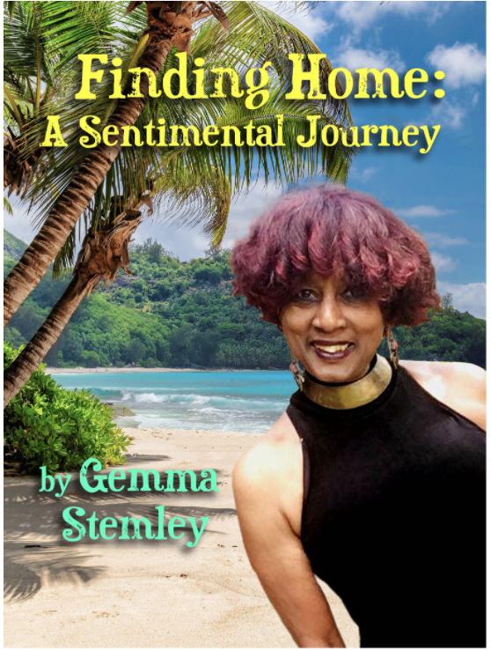
This is a fascinating, 236 page memoir penned
By Gemma Stemley, during the Covid pandemic.

“Mrs. Stemley takes the reader with her on a personal journey of belonging; specifically - where to claim as home. Her quest is multifaceted as she queries the meaning of the concept of home as an ‘emigre’, emigrant, immigrant, ex-pat, and hometown villager.

She masterfully weaves her experiences and familial culture aligned within the context of historical events and significance throughout the book. As she vividly shares her memories, Gemma intersperses a sprinkling of her poetry and literary connections, adding to the respective parts of the story narrative.”

This work will motivate one to read farther on Caribbean culture, early colonization, and rise to independence. It was even more gratifying to learn specifically about the author’s native Trinidad-Tobago, her hometown of El Dorado, Great Grandmother Julia’s Martinique(1902 volcanic eruption), and the emigration ancestry from India after slavery was abolished.

To Find this Book, GO TO:
- www.Amazon.com
SEARCH Finding Home: A Sentimental Journey by Gemma Stemley. The book’s image appears in the 1st position, top to bottom [BEST PRICE]

- www.thriftbooks.com/
SEARCH Finding Home: A Sentimental Journey by Gemma Stemley. The book’s image appears immediately and alone.

- Visit your local Library. Ask the Librarian.

CARIBBEAN NEWS…
Antigua – Barbuda:

Michael Browne returns to Cabinet on Monday, January 3, 2022

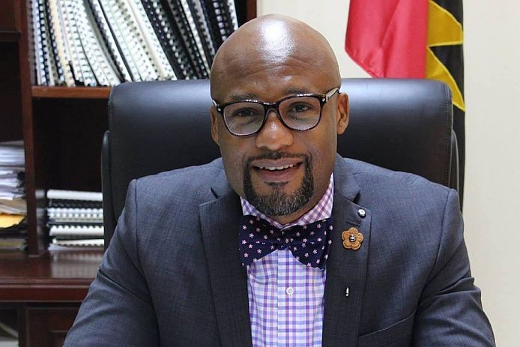
Prime Minister Michael Browne

ST JOHN’S, Antigua – Prime minister Gaston Browne has written to His Excellency the Governor-General to inform that “Michael Browne M.P. is to become a member of the Cabinet commencing Monday, January 3, 2022.”
The former minister had resigned his post more than a year ago when he faced a trial. Before being acquitted, Prime Minister Browne vowed to return the youthful parliamentarian to Cabinet, having determined that his skills and intellect, and the love of the people of the All Saints West Constituency, earn him a place in the executive body.
The prime minister has advised the Governor-General to appoint Michael Browne M.P. to the post of minister of the creative industries and Innovation, effective January 3, 2022.
The minister will have responsibility for Culture, Carnival, Independence, One Nation Concert, V.C. Bird Day Celebrations, Visual Arts, Graphic Arts, Decorative Arts, Performing Arts, Musical Arts, Happiness and Unity, Innovation, and the UNOPS.
Section 69(3) of the Antigua and Barbuda Constitution Order places the authority to determine portfolios within the Cabinet on the shoulders of the prime minister.
https://www.caribbeannewsglobal.com/antigua-barbuda-michael-browne-returns-to-cabinet-on-monday/
MORE CARIBBEAN NEWS…

Jamaica Begins Mineral Exploration
December 31, 2021 - By Garfield L. Angus
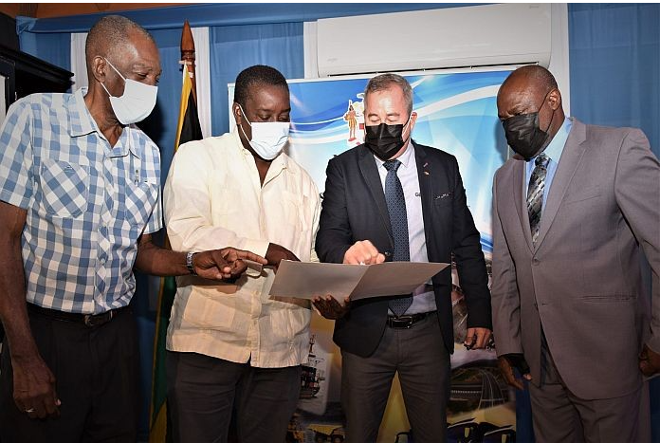
(Left-Right) State Minister in the Ministry, Minister of Transport and Mining J.C. Hutchinson; Minister of Transport and Mining Robert Montague; Managing Director of Geophysx Jamaica Limited Robert Stewart and Commissioner of Mines, Roy Nicholson. Photo: Mark Bell [Photo: Mark Bell]
KINGSTON, Jamaica (JIS) – Minister of Transport and Mining, Robert Montague is reporting that exploration work being done by Geophysx Jamaica Limited, is showing positive indications.
The company is licensed by the ministry and the National Environment and Planning Agency (NEPA), to explore copper, zinc, gold and other minerals. Geophysx is a mineral exploration group which operates with modern, yet economically, ecologically and sociologically sustainable techniques.
The minister, who was addressing a press conference to update the country on the next phase of surveys by the company, said the work has shown that “there is something else”.
“We are moving to confirmation and it will expand employment for our people, and we will earn foreign exchange for the country. There are exciting times
MORE CARIBBEAN NEWS…
ahead for mining, once we complete phase three of the Geophysx,” minister Montague added that he is anticipating that there will be some commercial finds, and based on “the results that we have in hand, we are very hopeful that we are going to find some things. We are going to push this and ensure that the environmental standards are maintained and kept”, he said. …………
Simply CLICK the LINK to CONTINUE READING the complete article:
https://www.caribbeannewsglobal.com/jamiaca-begins-mineral-exploration/

Barbados Builds Own Online Travel Booking Platform
~A Game Changer~

January 5th, 2022 –By Lebawit Lily Girma

“This is what action looks like, if Caribbean tourism is to build back better. Investment in technology, a solid private-public relationship, and homegrown talent driving the framework and the narrative.” - Lebawit Lily Girma

When the pandemic hit, the hospitality and tourism industry in the Caribbean wasn’t just hurt by the absence of visitors. It was faced with a larger conundrum: delayed payments from major international tour operators, such as TUI and Virgin Holidays, for services rendered in the first three months of 2020. By May 2020, 69 percent of hotels had reported being owed from $200,000 up to $15 million, according to the Caribbean Hotel and Tourism Association.
Two years on, a solution has emerged out of Barbados that could point to a groundbreaking model for the rest of the Caribbean region. Launched at the close of 2021, BookBarbados.com, a Barbadian-owned and independently funded and operated online travel booking platform, allows users to buy hotel stays ranging from luxury to budget, local tours, Airbnb rentals, and long term stays all in one place. The site also taps into local influencer recommendations for a more authentic version of the island.
It’s what Barbados and much of the region had been missing until now: an e-commerce and travel marketing platform that will place more of consumer’s vacation booking funds directly into local businesses’ hands, and a way to stand out with a homegrown depiction of Barbados that goes beyond the sun and sand narrative. …………
Simply CLICK the LINK to CONTINUE READING the complete article:
https://skift.com/2022/01/05/barbados-builds-its-own-online-travel-booking-platform-to-be-a-game-changer/?utm_campaign=Weekly%20Review%20Newsletter&utm_medium=email&_hsmi=200331957&_hsenc=p2ANqtz-_N0lmg8oRBvEpoYa-pnHvcvSoYrNM44urdbwXd7QbZHYF9cidzplrsYIm7NiF3RX3fIr1skrBl6fOEIWROymJoFHuLkg&utm_content=200330230&utm_source=hs_email

VEXILLOLOGY:
…The study of Flags…

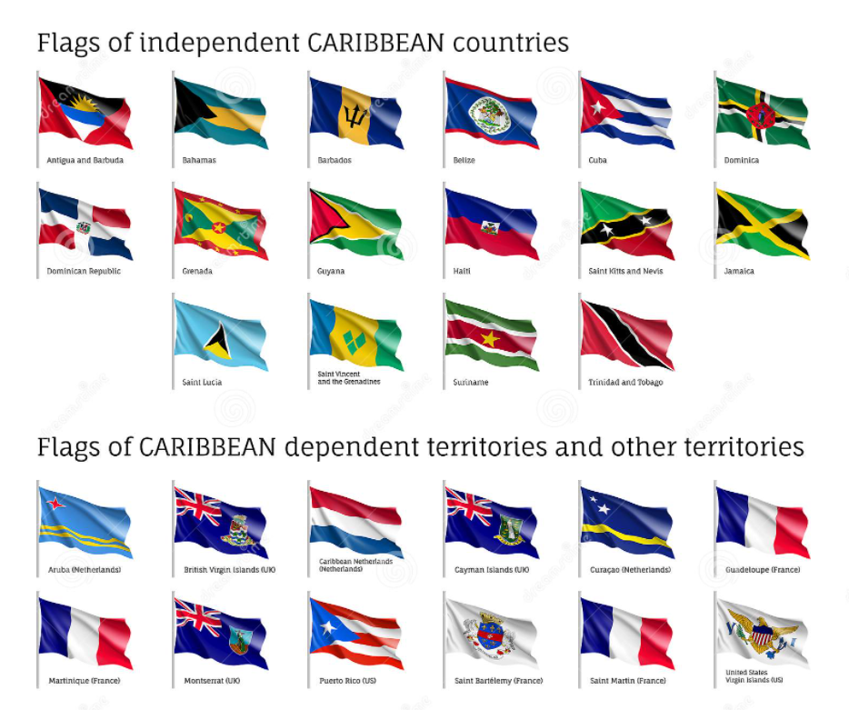

The Insider
A “CULTURE-ZINE”
Volume 1, Issue 3, January 2022

This E-ZINE is Created, Curated and Produced By

www.battleplanvirtual.com
For CARIBBEAN VILLAGE, Monroeville Mall, Monroeville, PA, 15146

PLEASE feel free to SHARE this publication WITH YOUR NETWORK

CONTACT CARIBBEAN VILLAGE AT 412 377 7951 or 412 805 9687 to PURCHASE A PAPER COPY of this CULTURE-ZINE

