The CARIBBEAN VILLAGE Insider CULTURE-ZINE
Volume 1, Issue 11, September 2022
Greetings Patrons, Partners and Friends,
WE ARE BACK with another CULTURE-ZINE issue JUST FOR YOU!!!
This E-ZINE is best viewed on a larger screen [larger than a smartphone screen] to get the full impact of the style, imagery and page turning feature that is also accompanied by the sound of the pages flipping.
Also, don’t forget that you can now visit, browse, shop and communicate with “The VILLAGE” via www.caribbeanvillageusa.com. We want to HEAR FROM YOU!!

As we state in each issue of The Insider, our objective is to educate, inspire and entertain our readers as we present content that is of interest to:
- The Caribbean diaspora, in particular, as well as,
- A multi-cultural diaspora, and also
- The Caribbean Enthusiast - anyone who is interested in the Caribbean Experience

The FOUNDER’S Notes
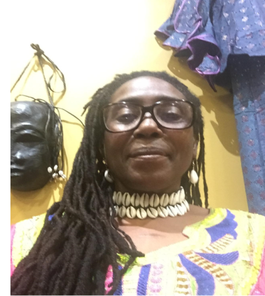
Greetings Friends!! This month we are excited to feature the Lush and Beautiful Saint Vincent and the Grenadines of the Lesser Antilles archipelago!

In this issue, we are thrilled to present an edifying interview with a Vincentian father and daughter. The interview was facilitated by yet another daughter who lives right here in Pittsburgh. Truly a Vincy Family Affair!

As usual, we have some timely, informative Caribbean News for you and MUCH MORE!!

I’ll see you INSIDE…

Table of Contents
Volume 1, Issue 11, September 2022

Page 1: Welcome and The Founder’s Notes
Page 2: Table of Contents
Page 3: The Flag and Coat of Arms of St.Vincent and the Grenadines
Page 4: Geography, HISTORY PERSPECTIVE, Government & Politics
Page 7: An Interview with Vincentians, Leona and Leon Sutherland
Interviewed By: Keywanda Battle
Page 12: Photo Array – Scenes from Saint Vincent and the Grenadines
Page 16 Gastro Caribe
Page 18: Kahila’s Taste
Page 20: CRUCIAN, By Way of ANTIGUA – Cheryl Joseph
Interviewed By: Keywanda Battle
Page 25: BOOKS of the Month
Page 27: CARIBBEAN NEWS
Page 32: The VEXILLOLOGY
Page 33: St Vincent and the Grenadines Flag Youth Coloring Page
Page 34: PRODUCER Information Page [Last Page]

To open the Links in this E-Zine, Simply CLICK the Link

The FLAG and Coat of Arms of Saint Vincent and the Grenadines [SVG]
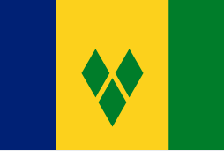
The flag of Saint Vincent and the Grenadines is a Canadian Pale triband consisting of blue, gold, and green bands charged with three green diamonds at the center. This flag design was adopted in 1985 to replace a similar design used from the time of independence. It has been the flag of Saint Vincent since that year.
The colors and symbols of the flag carry cultural, political, and regional meanings. The blue epitomizes the sky and the sea, while the gold represents the color of the islands' sand, the sunshine, and the "bright spirit" of the islanders. The green symbolizes the country's plentiful vegetation, as well as the vitality of Vincentians. The three diamonds evoke the sobriquet of Saint Vincent as the "Gems of the Antilles" and the "Jewels of the Caribbean". Their arrangement in the shape of the letter V is a subtle allusion to the first letter in "Vincent", while its placement on the marginally lower part of the center band indicates the geographical positioning of the islands within the Antilles.

Coat of Arms
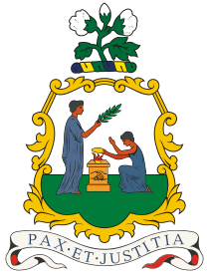
The coat of arms or national seal of Saint Vincent and the Grenadines is surmounted by a cotton plant and bears the text "Peace and Justice" in Latin. The centerpiece is based on the colonial badge in use from 1907 to 1979 and features two women in classical Roman dress. The one on the heraldic right stands holding an olive branch and the one on the left holds scales of justice and kneels before a gold altar situated between them.

GEOGRAPHY
GPS Coordinates are 12.9843° N, 61.2872° W
St. Vincent and the Grenadines is a southern Caribbean nation comprising a main island, St. Vincent, and a chain of smaller islands. The main island is home to the capital, Kingstown.
Saint Vincent and the Grenadines lies to the west of Barbados, south of Saint Lucia and north of Grenada in the Windward Islands of the Lesser Antilles, an island archipelago of the Caribbean Sea.
The islands of Saint Vincent and the Grenadines include the main island of Saint Vincent and the northern two-thirds of the Grenadines which are a chain of smaller islands stretching south from Saint Vincent to Grenada.
There are 32 islands and cays that make up St Vincent and the Grenadines (SVG). Nine are inhabited, including the mainland St Vincent and the Grenadines islands: Young Island, Bequia, Mustique, Canouan, Union Island, Mayreau, Petit St Vincent and Palm Island. Prominent uninhabited islands of the Grenadines include Petit Nevis, used by whalers, and Petit Mustique.
The island of Saint Vincent is volcanic and heavily forested and includes little level ground. The windward side of the island is very rocky and steep, while the leeward side has more sandy beaches and bays. Saint Vincent's highest peak is La Soufrière volcano at about 4,049 ft. Other major mountains on St Vincent are (from north to south) Richmond Peak, Mount Brisbane, Colonarie Mountain, Grand Bonhomme, Petit Bonhomme and Mount St Andrew.
The country is home to three terrestrial Eco-Regions: Windward Islands moist forests, Leeward Islands dry forests, and Windward Islands dry forests.
The northern two-thirds of the chain, including about 32 islands and cays, are part of the country of Saint Vincent and the Grenadines. The southern third of the chain belongs to the country of Grenada. CARICOM is the largest and most populous of the Grenadines.
The islands are politically divided between the island nations of Saint Vincent and the Grenadines and Grenada. They lie between the islands of Saint Vincent in the north and Grenada in the south. Neither Saint Vincent nor Grenada are Grenadine islands. The islands north of the Martinique Channel belong to Saint Vincent and the Grenadines and the islands south of the channel belong to Grenada.
Native citizens are referred to as “Saint Vincentian” or “Vincentian” or “Vincy”.
The currency is the Eastern Caribbean Dollar.

A HISTORICAL PERSPECTIVE of Saint Vincent and the Grenadines
The island now known as Saint Vincent was originally named Youloumain by the native Caribs. The Caribs inhabited Saint Vincent before the Europeans arrived, and it is possible still to find Carib artifacts in the island.
It is thought that Christopher Columbus sighted the island in 1498, giving it the name St Vincent.
Various attempts by the English and Dutch to claim the island proved unsuccessful. It was the French who were first able to colonize the island, settling in the town of Barrouallie on the leeward side of St Vincent in 1719.
The indigenous Garifuna people, who became known as the "Black Caribs", aggressively prevented European settlement on Saint Vincent until 1719 when some French people came from Martinique and began to grow coffee, tobacco, indigo, cotton and sugar cane with the help of African slaves.
There was a lot of “push and pull” between France and Britain to control St Vincent.
The British captured the island and drove out the French from Barrouallie during the Seven Years' War (1756–1763). This claim was confirmed by the Treaty of Paris (1763). The Seven Years’ War was a global conflict between Great Britain and France for global pre-eminence. Very European.
On taking control of the island in 1763, the British laid the foundations of Fort Charlotte and also brought with them enslaved African prisoners of war to work on the island plantations.
The Black Caribs however, opposed to the British presence and entered into open conflict against the British, starting the First Carib War, which lasted from 1772 to 1773.
During the Anglo-French War (1778–1783), the French recaptured St Vincent in 1779. The British regained control under the Treaty of Versailles (1783).
The uneasy peace between the British and the Black Caribs led to the Second Carib War, which lasted from 1795 to 1796. The Black Caribs were led by the Garifuna people and supported by the French.
The revolt and the uprising was eventually put down in 1797 by the British. A peace treaty agreement was made which resulted in almost 5,000 Black Caribs [Garifuna] being exiled to Roatán, an island off the coast of Honduras, and to Belize and Baliceaux in the Grenadines.
In 1834 slavery was abolished and people from the Portuguese island of Madeira and from India came to work as agricultural workers.
Vincentians are the descendants of African people brought to the island to work on plantations.
See the CARIBBEAN NEWS article on page 29 entitled, “Charles' succession stirs Caribbean calls for reparations, Removal of Monarch as Head of State”, under the sub-title, “The Caribbean and Britain”, to see how a historical perspective sharpens one's vision of the present, not the past.

GOVERNMENT and POLITICS
Saint Vincent and the Grenadines is a parliamentary democracy and constitutional monarchy, with Elizabeth II as Queen of Saint Vincent and the Grenadines.
Queen Elizabeth II is represented as head of state in the country by the Governor-General of Saint Vincent and the Grenadines, Susan Dougan, since 2019.
The office of Governor-General has mostly ceremonial functions including the opening of the islands' House of Assembly and the appointment of various government officials.
Control of the government rests with the elected Prime Minister and their cabinet. The current Prime Minister is Ralph Gonsalves, elected in 2001 as head of the Unity Labor Party.
The legislative branch of government has a single legislative chamber, the House of Assembly of Saint Vincent and the Grenadines, seating 15 elected members representing single-member constituencies and six appointed members known as Senators. The parliamentary term of office is five years, although the Prime Minister may call elections at any time.
The judicial branch of government is divided into district courts, the Eastern Caribbean Supreme Court and the Privy Council of the United Kingdom in London being the court of last resort.
The islands are politically divided between the island nations of Saint Vincent and the Grenadines and Grenada. They lie between the islands of Saint Vincent in the north and Grenada in the south. Neither Saint Vincent nor Grenada are Grenadine islands. The islands north of the Martinique Channel belong to Saint Vincent and the Grenadines and the islands south of the channel belong to Grenada.

To LISTEN to a sample of "Saint Vincent, Land so Beautiful", the national anthem of Saint Vincent and the Grenadines. The song was first performed in 1967 and was adopted as the national anthem upon independence from the United Kingdom in 1979. The lyrics were written by Vincentian musician and author, Phyllis Joyce McClean Punnett.
Click the link below
https://web.archive.org/web/20191116054623if_/https://www.navyband.navy.mil/anthems/anthems/saint-vincent.mp3

An Interview with Vincentians, Leona and Leon Sutherland

CARIBBEAN VILLAGE is thrilled to present an edifying interview with Vincentian Daughter and Father, Leona and Leon Sutherland
[This photo taken in London, Ontario, Canada]

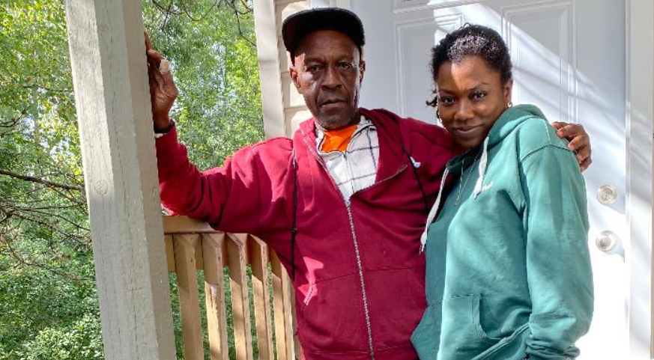

This interview was facilitated by yet another Daughter, Sarah Weaver, who lives right here in Pittsburgh. Truly a Vincy Family Affair!

As always, we remind our readers, that the goal of the interviews presented in The CARIBBEAN VILLAGE Insider CULTURE-ZINE is three faceted:
- We aim to edify our readers with informative, useful, little known and perhaps, unsung or undiscovered information about Saint Vincent and the Grenadines.
- We aim to delight our readers from Saint Vincent and the Grenadines and bring pleasant memories of HOME.
- We aim to imbue a curiosity in the reader - to want to learn more about this Beautiful archipelago.

Legend: CV = CARIBBEAN VILLAGE’S Question
LLS = Leona’s & Leon’s Answer

YES…. it’s time for our interview…..
CV: What is the current population of Saint Vincent and the Grenadines?
LLS: 111,ooo
CV: What ethnic groups make up the population?
LLS: The largest ethnic group was African (66%), followed by those of mixed descent (19%), East Indian (6%), Europeans (mostly Portuguese (4%), and Carib Amerindian (2%). There is a growing community of Chinese people in the country.
CV: What is the official language?
LLS: English is our official language.
CV: What language[s] do you usually hear on the streets?
LLS: English, English - Vincentian Creole
CV: What are the special customs or traditions?
LLS: Vincentians love a “day cook”! On the weekends, you can find Vincentians and tourists all over the island at different river spots and beaches, swimming, laughing, and cooking up a storm to feed everybody! Around Christmas time, it is custom to clean your entire home, change over your drapery, bake a lot, and prepare your best ham. Carnival is always the most anticipated time of the year, driving in tourists and visitors from all over the Caribbean diaspora.
CV: What are the most celebrated festival[s]/holiday[s]?
LLS: Carnival, Christmas - Nine Mornings [Nine Mornings before Christmas, Vincentians awake in the early hours of the morning and partake in a range of activities - among them sea baths, dances [or in local parlance, fetes], bicycle riding and street concerts. Also, Easter and Independence Day on October 27th.
CV: Is there a playful nickname or term of endearment that Nationals use amongst themselves?
LLS: My dad says, “dotish (stupid) man”, “ah foolish yuh foolish?”, “me good fren”.
CV: How have the islands been impacted by the COVID pandemic?
LLS: Tourism has fallen off considerably.
CV: What are the principal economic activities of SVG?
LLS: Our economy is heavily dependent on tourism, as well as, agricultural products such as sweet potatoes, plantains, yams, coconuts, and dasheens and eddoes [types of taro] and cocoa. Also, the La Soufriere volcano also erupted in April of 2021, which threw the whole country off course.
CV: Is there taxation?
LLS: The standard rate is 16% and a reduced rate of 11% [VAT] applies to goods and services supplied by hotels and the rental of berthing space from marinas and shipyards.
CV: What do you export/import?
LSS: The major imports are machinery and transport equipment, food and beverages, chemicals, and fuels, coming primarily from the United States and the Caribbean Community and Common Market [Caricom] countries, especially Trinidad and Tobago, and Venezuela.
The main exports are eddoes, dasheen, arrowroot starch, and cocoa. The country's main export destinations are the Caricom countries, particularly Saint Lucia, Trinidad and Tobago, Barbados, and Antigua and Barbuda.
Bananas used to be one of the largest exports, but there was the Black Sigatoka disease that ravaged the crops and that industry has dwindled.
CV: What are the main industries?
LSS: Our main industries are tourism, food processing, agriculture [sweet potatoes, cassava, arrowroot, cocoa and yam].
Saint Vincent and the Grenadines is the world’s top producer of arrowroots and clothing starch.
Relevant Definitions:
Taro - is a completely different kind of edible tuber than the potato. It is of the arum family which has edible starchy corms and edible fleshy leaves.
Arrowroot – is a West Indian herbaceous plant from which a starch is prepared. The fine-grained starch harvested from arrowroot is used in cooking and medicine.
CV: What is your most popular sport?
LLS: Football [soccer] for sure! There are always lots of openings and tournaments, where you are guaranteed to see every Vincentian dressed their best.
CV: Can you describe the seasons?
LLS: It is usually very tropical hot, and humid all year around, but around June to December it is the rainy season.
CV: What are your most popular tourist destinations?
LLS: La Soufriere volcano, the Grenadine islands such as Bequia, Dark View Falls, Fall of Baleine, Owia Salt Pond, Black Point Tunnel, Kingstown, Indian Bay, The Botanical Gardens, Fort Charlotte, and so much more!
CV: Is there interesting architecture?
LSS: There are lots of churches and cathedrals, colonial stone arches and walkways in Kingstown and very colorful homes. You will not see many buildings at all.
CV: Who are the notable artists and authors from SVG?
LSS: Kevin Lyttle, Becket, Skinny Fabulous, Fireman Hooper, Judy Boucher
CV: How easy is it to travel around the islands?
LSS: There is one made road that goes around the main land that branches off into other areas. Most places and villages are easily accessible by walking or driving, except if you need to go a long distance. There are some areas like the Falls of Baliene where a boat is needed to get there. The other grenadine islands are accessible by the water.
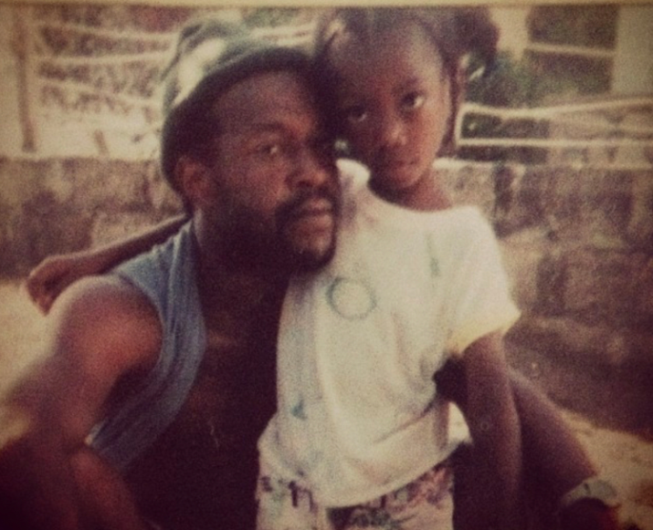
CARIBBEAN VILLAGE THANKS Leona and Leon Sutherland for sharing their knowledge in this illuminating interview about Saint Vincent and the Grenadines and Many Thanks to Sarah Weaver for making it possible through introduction.
~ Leon and Leona Sutherland ~ 1996

Scenes from Saint Vincent and the Grenadines
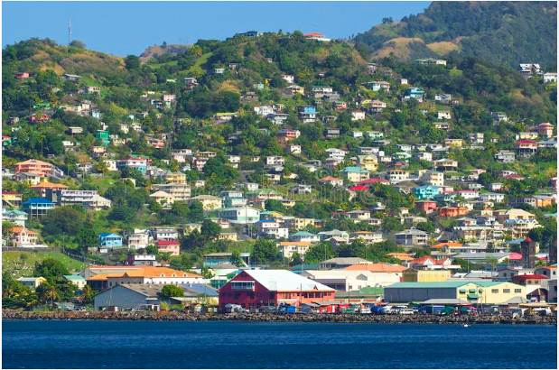

St Vincent panorama, Grenadines

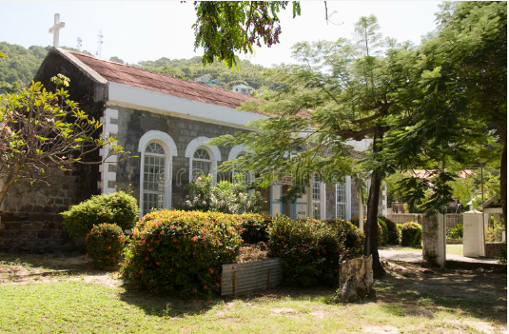
St.Mary’s Church, Bequia, St. Vincent

Scenes from Saint Vincent and the Grenadines
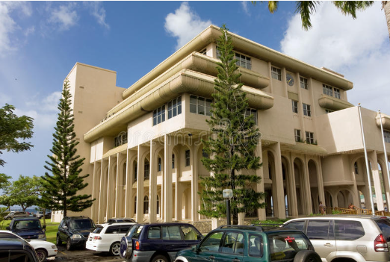

The Ministerial Building of St. Vincent and the Grenadines
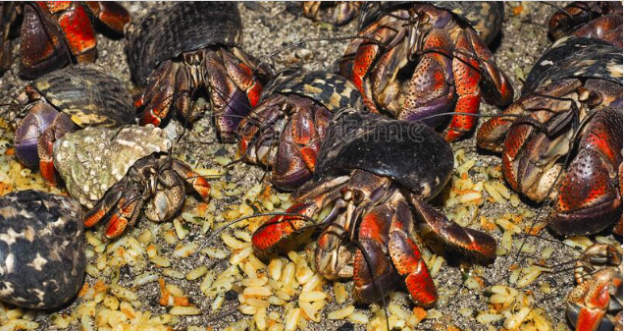Hermit crabs on Tobago Cays, St. Vincent and the Grenadines

Scenes from Saint Vincent and the Grenadines
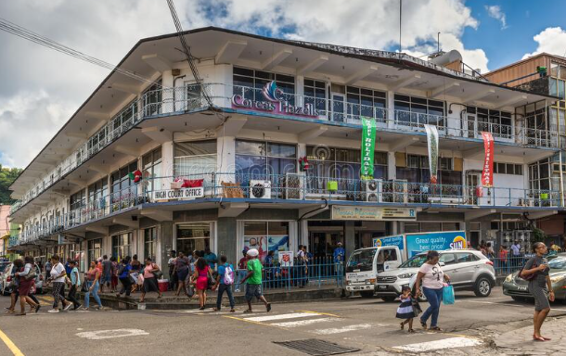Street life in Kingstown, St Vincent, Saint Vincent and the Grenadines
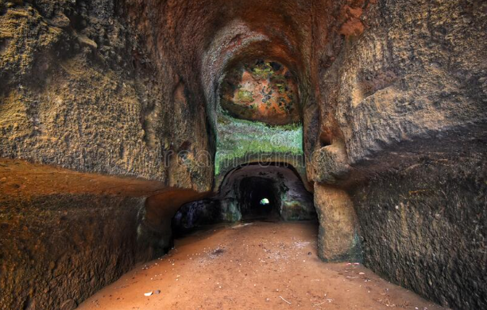Black Point Tunnel, St. Vincent

Scenes from Saint Vincent and the Grenadines
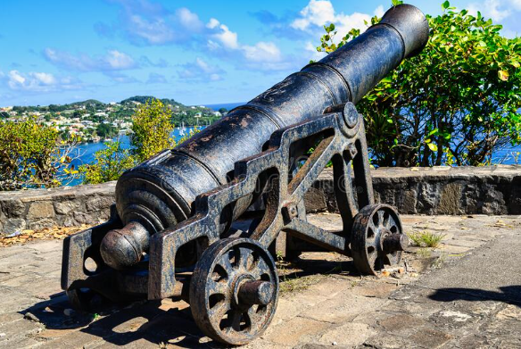A view of Fort Duvernette on St. Vincent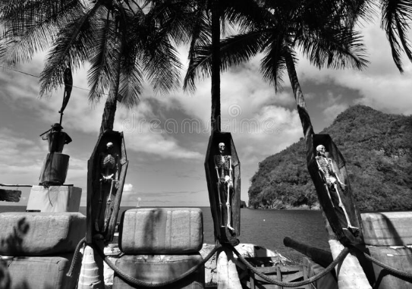
View of the Wallilabou Bay, where Pirates of the Caribbean, was filmed in 2003

GASTRO CARIBE

This monthly segment offers ISLAND recipes, food talk, serving advice and helpful tips.
We always start by defining GASTRONOMY - Gastronomy is the study of the relationship between food and culture, the art of preparing and serving rich or delicate and appetizing food, the cooking styles of particular regions, and the science of good eating.
The National Dish of Saint Vincent and the Grenadines

Roasted Breadfruit & Jackfish
This satisfying, savory combination of roasted breadfruit and fried jackfish is frequently enjoyed as a full lunch choice. The whole breadfruit is traditionally roasted over an open fire until it is slightly browned on the exterior but still soft and delicate in the middle, then coated in flour and fried until crispy. The fish is frequently marinated in lemon juice. A sauce made with onions, tomatoes, garlic, thyme, or other vegetables and herbs is usually served alongside the dish. Try this delicious and simple recipe for your family!!
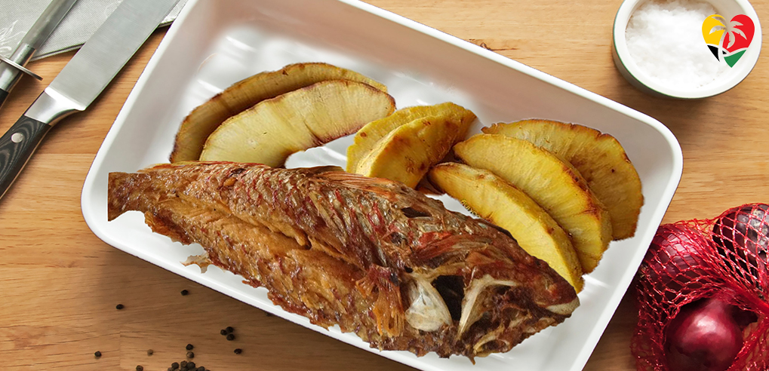

~Every August the islands celebrate a Breadfruit Festival~

WHAT YOU NEED:
- 1 lg. Breadfruit
- 1 lb. jackfish
- 1/4 cup oil
- 1/4 cup minced seasoning (chive, garlic, thyme)
- 1 cup Flour for coating (add as desired)
- Lime or lemon juice
- 1 tbsp salt

WHAT TO DO:

Pierce the Breadfruit with a fork or skewer, before placing it in the oven for roasting. Bake the Breadfruit in a moderate oven (250F to 350F) for about 1 1/2 hours or until soft. [Optional: To make it stand straight, cut a tiny slice off the bottom]
- Clean the fish. Pour lemon juice over the fish and leave to marinate for about 15 minutes. Rinse and dry with paper towels
- Add salt to minced seasoning and rub seasoning over fish and set aside
- Coat fish on both sides in flour - remove excess flour
- Put oil in a frying pan to heat
- Fry fish for approximately 4 minutes on each side or until brown
- Serve with sliced Breadfruit

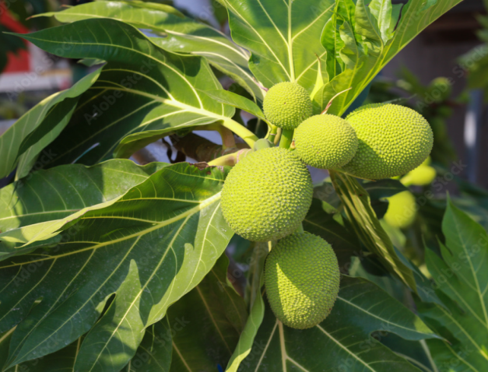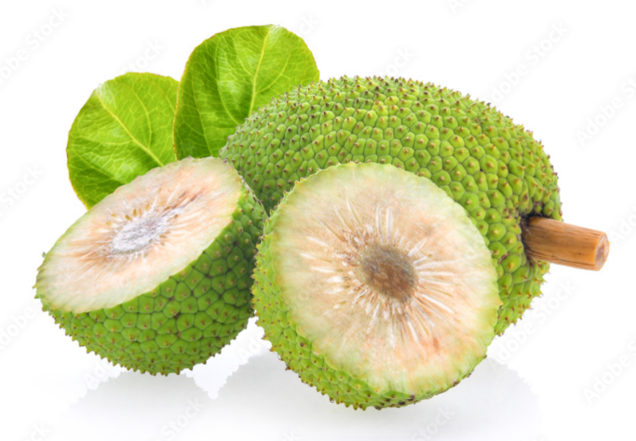

Kahila’s Taste
“Wha You Ah Sey??”
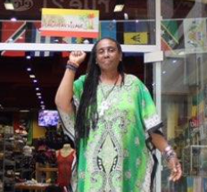
I want to do something different this month! Let’s explore the meanings and culture and humor of our language and dialects across the islands, countries or regions from which we come.
I believe it’s safe to say that the un-initiated [Non-Caribs] may initially have some serious trouble understanding the dialect, the pronunciation, the phrasing and the meaning of words, statements and general conversation spoken in all our Caribbean-ness. Catching on can be a bit tricky, but once you get the hang of it, you'll be on your way to becoming an expert in patois and Caribbean creole in no time. Yours ears will probably catch on more quickly than your tongue.
To prove my point, here are a few Caribbean sayings and proverbs along with their meanings. The question is - without the meanings would YOU understand???
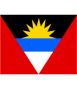Antigua - “A no wantin tongue mek cattle can't talk”
Meaning - it's sometimes wisest to keep one's mouth shut.

Antigua – “A word betta dan a wink fo a bline horse”
Meaning - Use the right motivation for each person

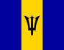Barbados – “A eyeful en a bellyful”
Meaning - Seeing is different from having

Barbados – “Better fish in di sea dan wha get ketch”
Meaning - There's always a better lover than your current one

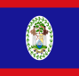Belize – “A lia is fugetful”
Meaning - A dishonest person can't remember to keep his story straight.

Belize – “Bad ting neva got owner”
Meaning - No one wants to take responsibility for a mistake or bad situation

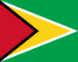Guyana – “All cassava get same skin but all nah taste same way”
Meaning - People may look alike, but all act differently

Guyana – “Every rope gat two ends”
Meaning - Every story has two sides.

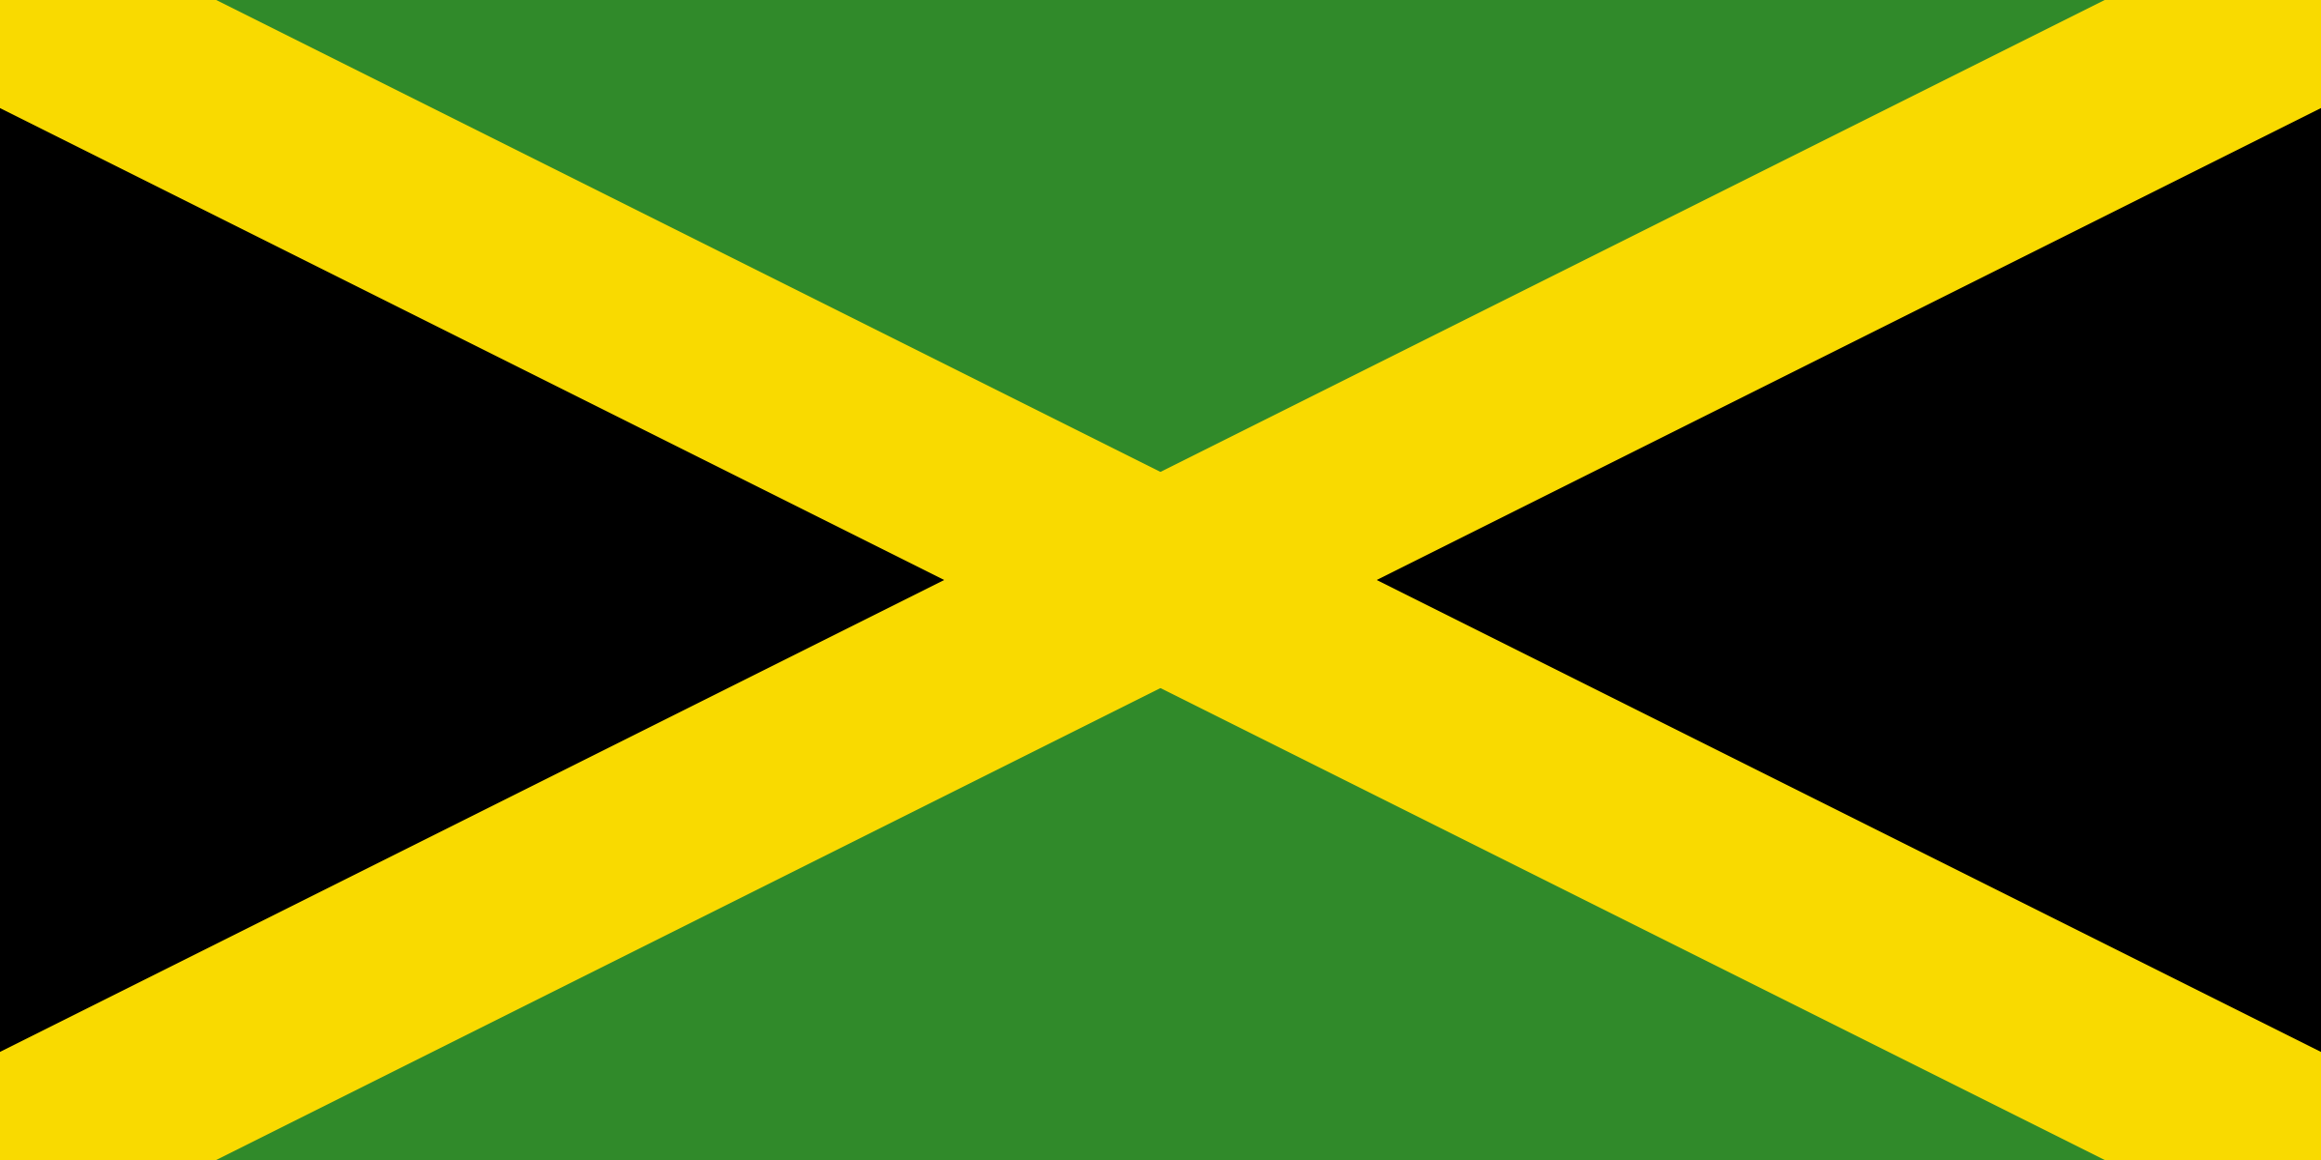Jamaica – “Tank yu' nu buy half bit bread”
Meaning - Payment is more useful than expressions of gratitude

Jamaica – “A faas mek anansi de a house top”
Meaning - It is dangerous to meddle in the affairs of others

Also, would you agree that it is very Caribbean to describe a person in terms of their anatomy? Being all in good fun, of course! - like “Big Booty Judy” or “Skinny Fabulous” [SVG].
Send us some of YOUR island’s ordinary or familiar phrases used in everyday conversation along with the interpretation/meaning and we may include it in a future installment of “Wha You Ah Sey??”
You can submit the entries via the Contact Page [Get in Touch] at the website – www.caribbeanvillageusa.com or Email: keywandabattle@yahoo.com

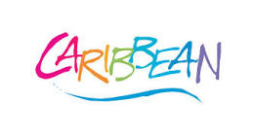

A CRUCIAN By Way of ANTIGUA

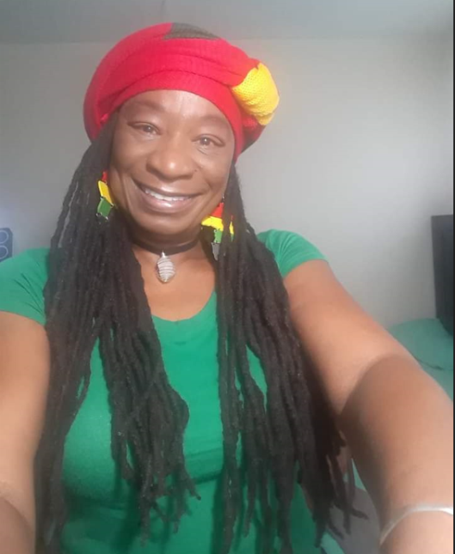

This 6 question follow-up interview with Educator, Cheryl Joseph, is purposed to provide our readers with a more personalized view and understanding of her journey from start to NOW. Ms. Joseph’s perspective is presented to give her voice to the voyage of the Caribbean diaspora.

LEGEND:
CV = CARIBBEAN VILLAGE’S Question [by number]
CJ = Cheryl Joseph’s Answer

The Interview….

CV Q1: Tell us about your journey from your birth, your stops along the way, and how you happened to arrive in Pittsburgh.
CJ: Where should I start? I’ll begin before my beginning.
My parents basically migrated from their land of birth, Antigua, in pursuit of a better way of life via working opportunities. The norm in most Carib families who wanted to take a journey was to venture to England or the United States for a better way of life for the family as a whole.
When my parents settled in St. Croix, somewhere along the line, my mother became pregnant with me. I was told that her stomach was so big, the doctor told her she was going to have twins. My mom then returned to Antigua to give birth to me. Only to find out it was just me. (smile).
After 6 to 7 months my mom returned to St. Croix. All of my schoolings from pre-school up the high school occurred in St. Croix. I graduated in 1983.
A year later I joined the U.S. Army. I did a year and managed to get out with an Honorable Discharge status.
In 1986, I had my first daughter. Between 1986 through 1996 were my child-bearing years. I birthed 3 girls and 1 boy, in that order. I was basically a stay- at- home mom. A “soccer mom”, they call it? After the birth of my son, born in 1996, I decided to go back to school.
I enrolled in the community college, then called The College of the Virgin Islands, now called The University of the Virgin Islands. Due to personal and financial reasons, I had to drop out.
Pressing forward, in 2002 I enrolled in a Certified Nursing Assistant (CNA) program. I later got a job in that field to take care of an elderly man. Fast forward to 2005, I got hired by the local government as a paraprofessional working with Special Needs students in the high school.
It was not until 2010, when I decided to go back to school again. I transferred my local college credits to an on-line college, Ashford’s University in Iowa. I acquired a Bachelor’s Degree in Early Childhood Education Administration and a Master’s Degree in Elementary Education.
Presently, my hard work has paid off. I am now in my 17th year as a teacher. I live one day at a time. When I feel the need for a change of scenery I jump on a plane and take flight.
My son did his schooling in Pittsburgh. He liked it, and decided to stay. And this is how I found myself in Pittsburgh. I am humbled by CARIBBEAN VILLAGE’S interest in the story of my journey.
CV Q2: What are your motivations and what do you bring to the Caribbean Community?
CJ: I am an elementary school teacher. I must say, my students and my working staff motivate me. As a teacher, I get very empowered when my students grasp the concepts and comprehension of the lessons taught in my classroom. It’s like energy to my mind, body, and soul. I am working with some of the most remarkable and beautiful people. My working staff and my students give me the motivation to wake up every morning to go out to work.
I LOVE what I do. I am in my seventeenth year of teaching. I love every moment of it. Teaching is my life.
Another thing that motivates me is my love for arts and crafts. I always had a love for art. I paint with acrylics. My first paintings are in the abstract form. I also love handy crafts.
I created an art form using mask and paint and fabrics on canvas. This has never been created by anyone. I have sold many on island, as well as, stateside.
CV Q3: Can you name an accomplishment of which you are most proud?
CJ: One accomplishment of which I am most proud is the acquisition of my degrees. I have acquired a Bachelor’s Degree in Early Childhood Education Administration and a Master’s Degree in Elementary Education.
CV Q4: What are your goals for the future?
CJ: My goals for the future are:
- To retire and pursue my love for the arts. Art gives me that sense of calm I need. I love Pittsburgh, but not to take up permanent residence because I cannot deal with the cold. Brrrrrrr.
- I would also like to create some of my art work to add to Pittsburgh’s Caribbean cultural and retail scenes.
CV Q5: How do you summarize your love for your islands and people?
CJ: The Virgin Islands is home for me. Even though I was born on the island/country of Antigua, I still consider St. Croix to be my home because I was educated there and grew there during my formative years. Really and truly the Virgin Islands community is all that I really know.
I had the wonderful privilege to return to my place of birth this past summer. Although it was the shortest 2 weeks I’ve ever had, I was able to see family members from my early childhood. The last time I visited was forty years ago. Wow!, how quickly time flies [Chuckle in disbelief and nostalgically].
But yeah, the Virgin Islands is home.
I will go out on visits, but would always return home to the V.I. I also know that I will not stay away from my country/island of Antigua as long as I did in the past.
As for my community, manners, reflective of home training, are a big deal as in most of the Caribbean countries including the Virgin Islands. For example, if you walk into an establishment without saying good morning, afternoon, or good evening, it’s as if you have committed a crime. Somebody is going to hear about it.
CV Q6: What activities are you involved in to bring understanding about the U.S.V.I.?
CJ: I am part of the Black History team at my school, and also a part of the Local Cultural Bearers Committee. The job is to educate our students and locals about the culture of our people, as well as bringing awareness of our ancestors to enable love and unity amongst our people.
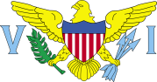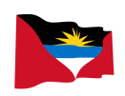

Again, CARIBBEAN VILLAGE THANKS Ms. Joseph for her transparency through the detailed, honest and intensely interesting answers to our questions designed to satisfy the inquiring minds of our readers.

Books of the MONTH

Shape Of A Warrior By Vincentian Author Peggy Carr
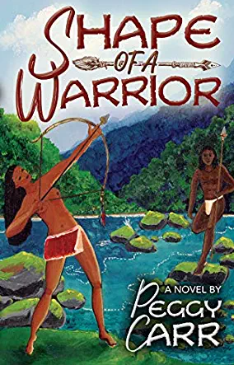
Right from the first page I was hooked and could not put this book down. It is an absolute page turner.
The author undoubtedly knows her subject well and it is apparent from the first page that the historical elements in this novel were thoroughly researched and put together to provide the backdrop for the riveting fictional story set in the beautiful Caribbean country of St Vincent and the Grenadines (Hiroon).
The characters are well developed, with very real, complex personalities and each with a very distinctive voice. I was so drawn into their lives, I cried with them and at times laughed so hard, I had to hold my sides. This is one of those rare stories that weaves itself into the reader’s imagination so that you feel as though you are there in that time and place with the characters.
This book carries the reader along, through conflict, friendship, loyalty and love, from beginning to end. Extremely well written, flowing seamlessly from each sentence to the next, each paragraph to the next and each chapter to the next makes it a most enjoyable and relaxing read. [~Review from a previous reader~]
To Find this Book, GO TO:
www.Amazon.com
SEARCH: Shape of a Warrior By Peggy Carr
OR…..Visit your local Library

Books of the MONTH

The Green Legacy of St. Vincent and the Grenadines: The King's Hill Forest Act of 1791 and the St. Vincent Botanic Garden By Inga Rhonda King

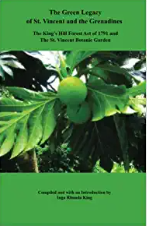
Inga Rhonda King is a Saint Vincent and the Grenadines accountant, teacher and publisher who has served as the country's Permanent Representative to the United Nations since September 2013.
The Green Legacy of Saint Vincent and the Grenadines is a Pictorial Tribute To the oldest Botanic Garden in the Western Hemisphere and one of the world's first pieces of Environmental Legislation.

To Find this Book, GO TO:
www.Amazon.com

SEARCH: The Green Legacy of St. Vincent and the Grenadines: The King's Hill Forest Act of 1791 and the St. Vincent Botanic Garden By Inga Rhonda King
OR…..Visit your local Library

CARIBBEAN NEWS

Saint Vincent and the Grenadines
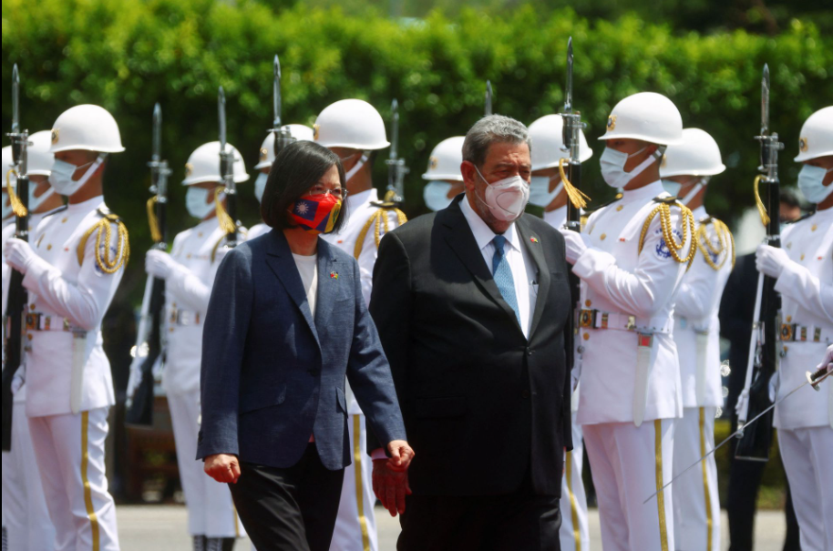
Taiwan President Tsai Ing-wen and Saint Vincent and the Grenadines Prime Minister Ralph Gonsalves review the honor guard during a welcome ceremony outside the presidential palace in Taipei, Taiwan August 8, 2022.

Taiwan's Tsai 'deeply touched' by St Vincent PM's visit amid China tension
Taiwan President Tsai Ing-wen told visiting St. Vincent and the Grenadines Prime Minister Ralph Gonsalves on Monday that she was moved by his determination to visit Taiwan, despite China's recent military exercises around the self-ruled island.

"Prime Minister Gonsalves has expressed in recent days that the Chinese military drills would not prevent him from visiting friends in Taiwan. These statements have deeply touched us," Tsai said at a welcome ceremony for Gonsalves in Taipei.

CARIBBEAN NEWS

The prime minister of the Caribbean country - one of around a dozen nations to have formal diplomatic ties with Taiwan - said he was on the island to express solidarity, strengthen bilateral relations and pursue peace, security and prosperity for all.

"As in our own hemisphere, the Western hemisphere, we do not like it and we do not support it when any powerful neighbor seeks to intimidate us or bully us," Gonsalves said. "Wherever there are differences, we must settle them peacefully in a civilized manner."

This is Gonsalves's twelfth visit to Taiwan, and the eleventh as prime minister, "clearly demonstrating the importance that he attaches to diplomatic relations between our countries," Tsai said.

In recent days, China has held unprecedented military exercises in the waters surrounding Taiwan and launched ballistic missiles over the island's capital for the first time.

The drills were launched in response to a visit to the self-governing island by U.S. House of Representatives Speaker Nancy Pelosi last week and were initially scheduled to end on Sunday, the day Gonsalves arrived in Taiwan for a six-day visit.

China's military said on Monday that it is continuing drills in the seas and skies around Taiwan.

China has never renounced the use of force to bring Taiwan under its control and claims the island as its own territory.

Taiwan's government says China has no right to speak for it or claim sovereignty, saying only Taiwan's people can decide their own future and the People's Republic of China has never controlled any part of the island.

Please click the link below to see date/day and article authorship references:
https://www.reuters.com/world/china/taiwans-tsai-deeply-touched-by-st-vincent-pms-visit-amid-china-tension-2022-08-08/

Caribbean nation of Saint Vincent exports first cargo of Medical Cannabis
Saint Vincent and the Grenadines has exported a cargo of 110 pounds (49.8 kilos) of medical cannabis after receiving a license for export to Germany, according to official announcements and a local official familiar with the matter.

CARIBBEAN NEWS

Saint Vincent, a Caribbean nation with a population of just over 110,000 people, has for years developed its local cannabis industry. In 2018, Saint Vincent created a state agency to oversee licensing and ensure its medical cannabis is available to local patients.

The shipment left on Jan. 18 and is expected to arrive in Germany on Jan. 19, said the official, who asked not to be named because he is not authorized to speak publicly about the matter.

The cargo was sold by Caribbean Cannabis Company, which already markets several products locally, according to the source.

Caribbean Cannabis Company did not respond to a request for comment.
St Vincent Agriculture Minister Saboto Caesar said on Jan. 7 that Germany's Federal Institute for Drugs and Medical Devices had approved a license for the shipment.

"St. Vincent and the Grenadines is ready for global business in the Medicinal Wellness Industry space," Caesar said, adding the government hopes to develop other wellness products including traditional medicines and the emerging field of psychedelic medicine.

He said it was the first medical cannabis export by a member of the Organization of Eastern Caribbean States, made up of 11 nations and overseas territories on the eastern edge of the Caribbean Sea.

Please click the link below to see date/day and article authorship references:
https://www.reuters.com/business/healthcare-pharmaceuticals/caribbean-nation-saint-vincent-exports-first-cargo-medical-cannabis-2022-01-20/

The Caribbean and Britain

Charles' succession stirs Caribbean calls for reparations, Removal of Monarch as Head of State
The ascension of King Charles to the British throne has stirred renewed calls from politicians and activists for former colonies in the Caribbean to remove the monarch as their head of state and for Britain to pay slavery reparations.
Charles succeeds his mother, Queen Elizabeth, who ruled for 70 years and died on Thursday afternoon.

CARIBBEAN NEWS

The prime minister of Jamaica said his country would mourn Elizabeth, and his counterpart in Antigua and Barbuda ordered flags to half-staff until the day of her burial.

But in some quarters, there are doubts about the role a distant monarch should play in the 21st century. Earlier this year, some Commonwealth leaders expressed unease at a summit in Kigali, Rwanda, about the passage of leadership of the 54-nation club from Elizabeth to Charles.

And an eight-day tour in March by now heir-to-the-throne Prince William and his wife, Kate, to Belize, Jamaica and the Bahamas was marked by calls for reparation payments and an apology for slavery.

"As the role of the monarchy changes, we expect this can be an opportunity to advance discussions of reparations for our region," Niambi Hall-Campbell, a 44-year-old academic who chairs the Bahamas National Reparations Committee, said Thursday.

Hall-Campbell sent condolences to the Queen's family and noted Charles' acknowledgment of the "appalling atrocity of slavery" at a ceremony last year marking the end of British rule as Barbados became a republic.

She said she hopes Charles would lead in a way reflecting the "justice required of the times. And that justice is reparatory justice."

More than 10 million Africans were shackled into the Atlantic slave trade by European nations between the 15th and 19th centuries. Those who survived the brutal voyage were forced to labor on plantations in the Caribbean and the Americas.

Jamaican reparations advocate Rosalea Hamilton said Charles' comments at the Kigali conference about his personal sorrow over slavery offered "some degree of hope that he will learn from the history, understand the painful impact that many nations have endured 'til today" and address the need for reparations.
The new king did not mention reparations in the Kigali speech.

The Advocates Network, which Hamilton coordinates, published an open letter calling for "apologies and reparations" during William and Kate's visit.

CARIBBEAN NEWS

The Queen's grandchildren have the chance to lead the reparations conversation, Hamilton added.

Jamaica's government last year announced plans to ask Britain for compensation for forcibly transporting an estimated 600,000 Africans to work on sugar cane and banana plantations that created fortunes for British slave holders.

"Whoever will take over the position should be asked to allow the royal family to pay African people reparations," said David Denny, general secretary of the Caribbean Movement for Peace and Integration, from Barbados.

"We should all work towards removing the royal family as head of state of our nations," he said.

Jamaica has signaled it may soon follow Barbados in ditching royal rule. Both remain members of the Commonwealth.

An August survey showed 56% of Jamaicans favor removing the British monarch as the head of state.

Mikael Phillips, an opposition member of Jamaica's parliament, in 2020 filed a motion backing the removal.

"I am hoping as the prime minister had said in one of his expressions, that he would move faster when there is a new monarch in place," Phillips said on Thursday.

Allen Chastanet, a former St. Lucia prime minister and now leader of the opposition, told Reuters he backed what he said was a "general" movement toward republicanism in his country.

"I certainly at this point would support becoming a republic," he said.

Please click the link below to see date/day and article authorship references: https://www.hindustantimes.com/world-news/charles-succession-stirs-caribbean-calls-for-removal-of-ruler-as-head-of-state-101662690905936.html

VEXILLOLOGY

…The Study of FLAGS…
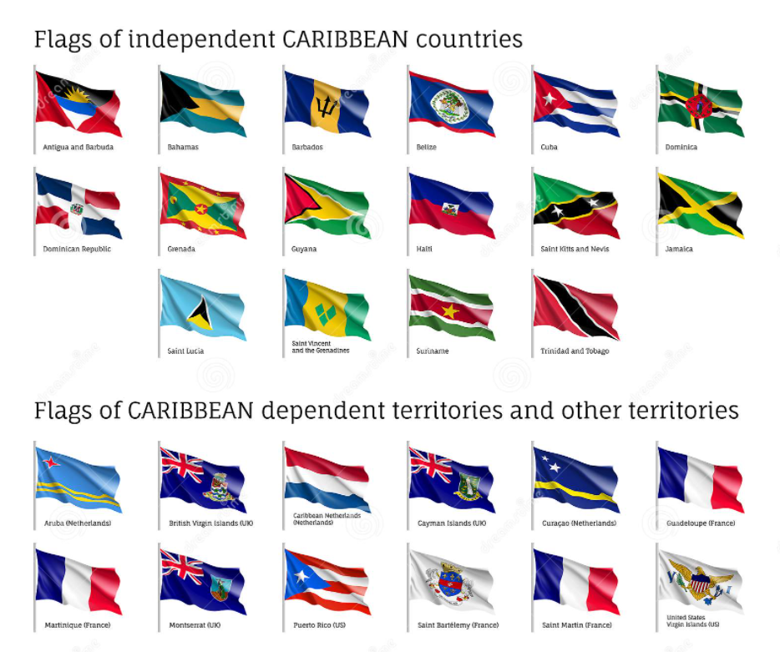

Flag Knowledge, Terminology and Definitions
A Canadian Pale is a center and of a vertical triband flag (a pale in heraldry) that covers half the length of a flag, rather than a third as in most triband designs. This allows more space to display a central image (common charge) as with the SVG flag.
The classic Canadian Pale is a square central panel occupying half of a flag with 1:2 proportions. However, vexillological usage applies it to any central band that is half the width of the flag, even if this renders it non-square.
The term Canadian Pale is also used for flags which do not originate in Canada. The term is sometimes used in an even looser sense to refer to any flag with a larger central panel, irrespective of whether or not it covers half the flag.

Saint Vincent and The Grenadines FLAG Youth Coloring Page

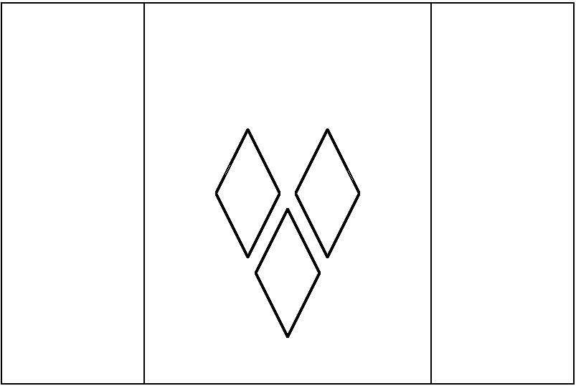

The flag of Saint Vincent and the Grenadines is a Canadian Pale triband.
For more information: See The VEXILLOLOGY on Page 32.
The colors and symbols of the flag carry cultural, political, and regional meanings. The blue epitomizes the sky and the sea, while the gold represents the color of the islands' sand, the sunshine, and the "bright spirit" of the islanders. The green symbolizes the country's plentiful vegetation, as well as the vitality of Vincentians. The three diamonds evoke the sobriquet of Saint Vincent as the "Gems of the Antilles" and the "Jewels of the Caribbean". Their arrangement in the shape of the letter V is a subtle allusion to the first letter in "Vincent", while its placement on the marginally lower part of the center band indicates the geographical positioning of the islands within the Antilles.

The CARIBBEAN VILLAGE Insider CULTURE-ZINE
Volume 1, Issue 11, September 2022

This E-Zine is Created, Curated and Produced By

www.battleplanvirtual.com
For CARIBBEAN VILLAGE, Monroeville Mall, Monroeville, PA, 15146

PLEASE feel free to SHARE this publication WITH YOUR NETWORK

CONTACT CARIBBEAN VILLAGE AT 412 377 7951 or 412 805 9687 to PURCHASE A PAPER COPY of this CULTURE-ZINE

